**REPORT ON EXERCISE 3**

**DATA PROCESSING ON RISCAN AND ARCGIS SOFTWARE: HANSBREEN GLACIER**

BY

CHUKWU CHINYERE PRECIOUS

Field observation was carried out on Hansbreen glacier located in Svalbard using the Rielg VZ_6000 instrument, with the scan taken on mutton in front of Hans glacier. Two scans were obtained from this observation. Scan from 2020-08-17 and 2020-08-28.

The two scans with .rim extension were uploaded into the Riscan software by a drag and drop of those files into the new project window. Each dataset has a cliff and Panorama observation, the dataset was named accordingly.

* **.mon file**

.mon is a file extension that accompanies the main point cloud of every scan. This file can either be deleted or not deleted. In any case, the file is not useful for data processing, therefore in a case where we have large data to process, it is better to delete this file. This file was deleted in this exercise by right clicking on the file and then delete.

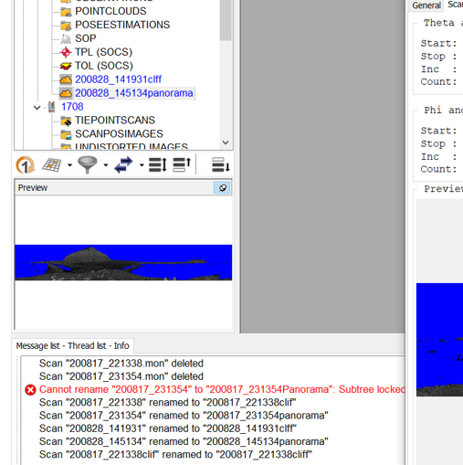

Each scan has two dataset with the name cliff and panorama. The major difference between this two dataset is, while the cliff scan shows only area with cliff, panorama shows the whole horizon of the area.

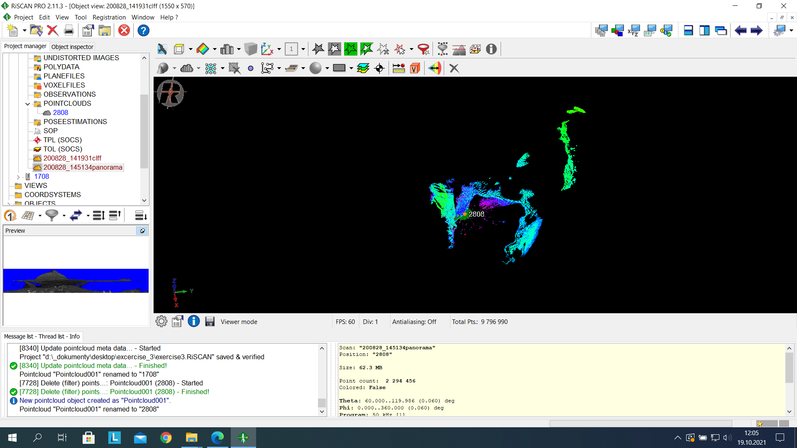

* **Analyzing the attribute of both scans**

We made analyses on the attributes of both scans. It was observed that the same parameter was used for the panorama of both scans and the same parameter was also used for the cliff of both scans. For panorama scans, resolution is 0.060deg, measured point is 6037006, estimated time of observation is 14minutes, and frequency is 50 kHz. For cliff scans, resolution is 0.0040deg, measured point is 10284866, estimated time of observation is 18minute, and frequency is 50 kHz. This can be seen from the images below, the first image represents panorama while the second image represents the cliff properties.

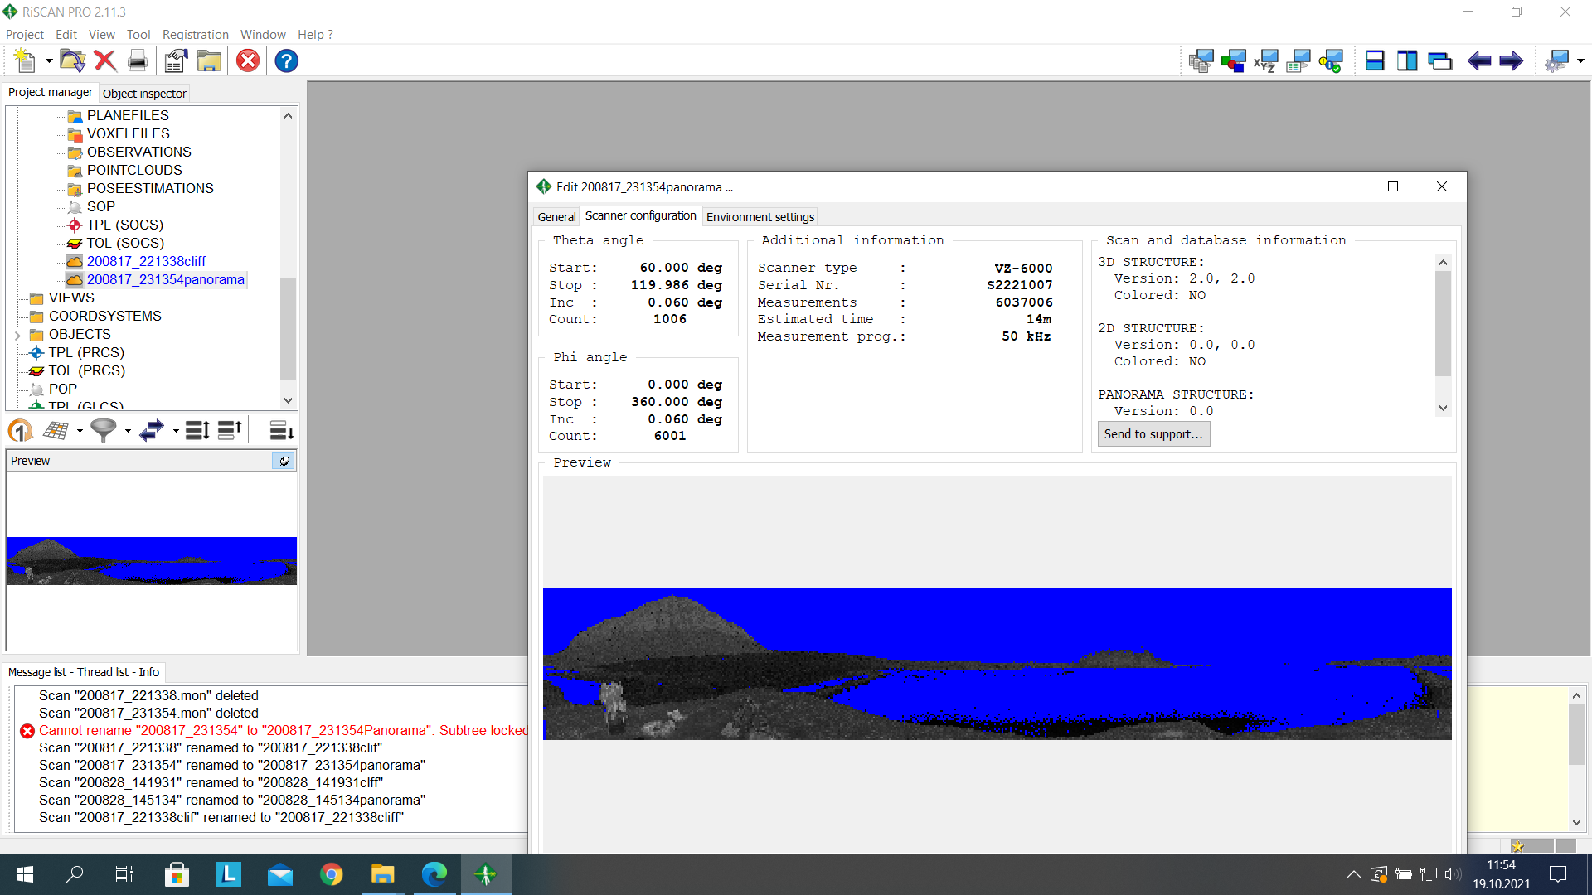

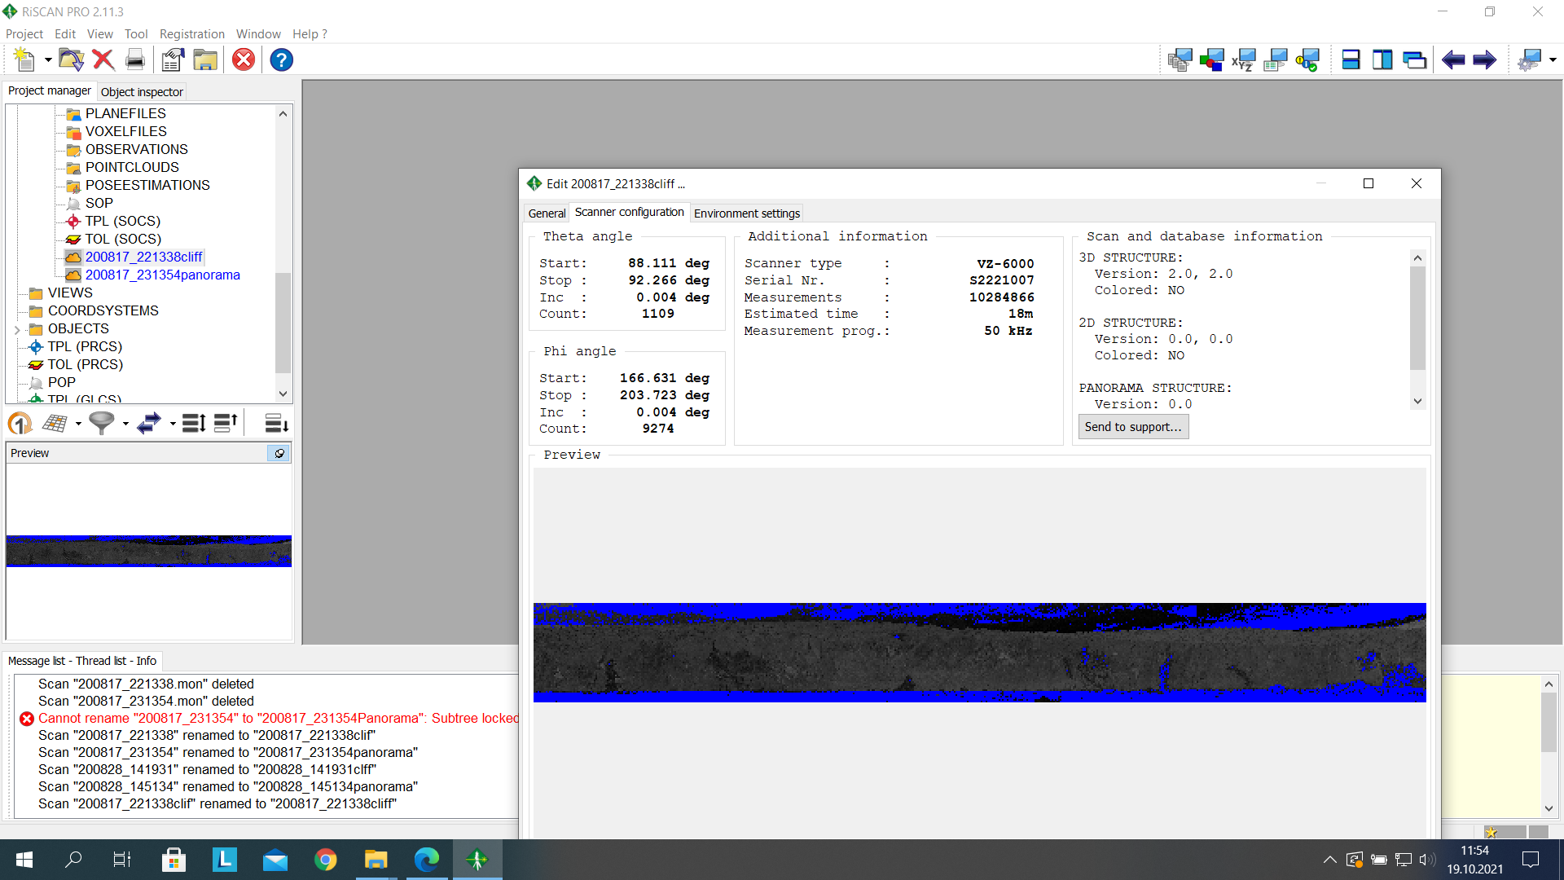

* **Exporting to a new dataset**

After the display of both scans, stable area was exported into a new point cloud dataset. The selection tool was used to select this area and by using the point cloud tool, the selected area was created into a new pointclouds file and it was renamed accordingly.

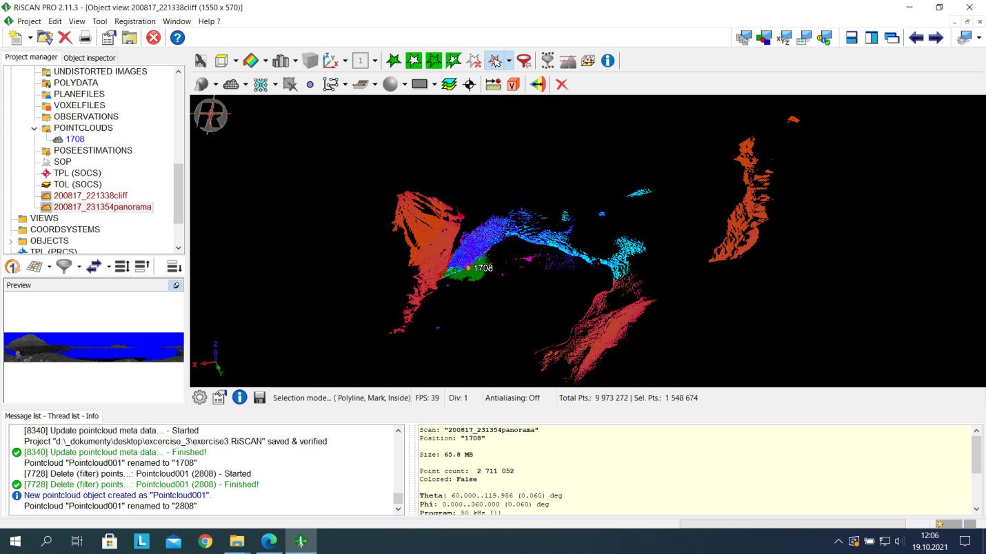

* **Registration of the point clouds**

Scan registration procedures were carried out on the exported scans. Both scans were set into different colors using the “modify orientation and position in 3D view” options one pointcloud was oriented to fit closely into the second point cloud.

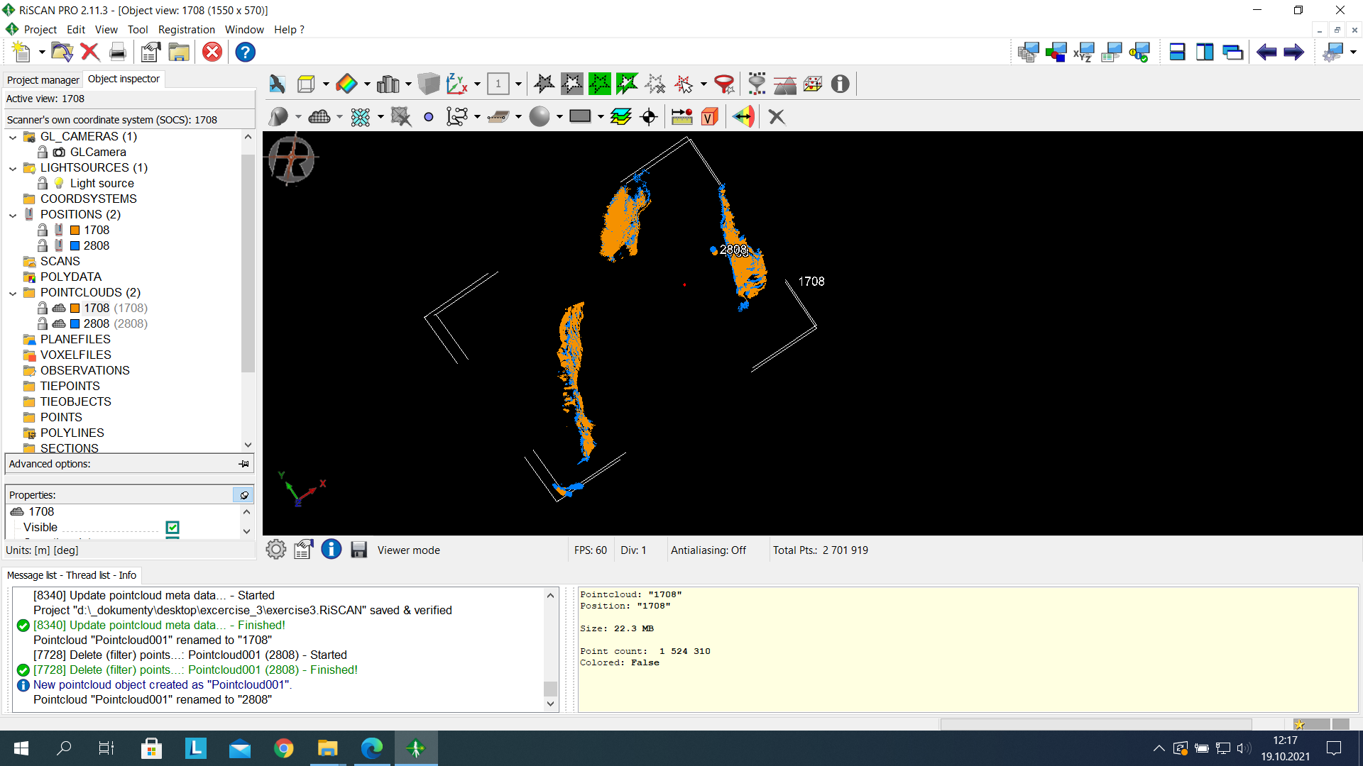

Using the normal setting In the “Extract plane patches” dialogue box, for both scans, the generated plane patches have fewer points of about 138 as can be seen from the image below.

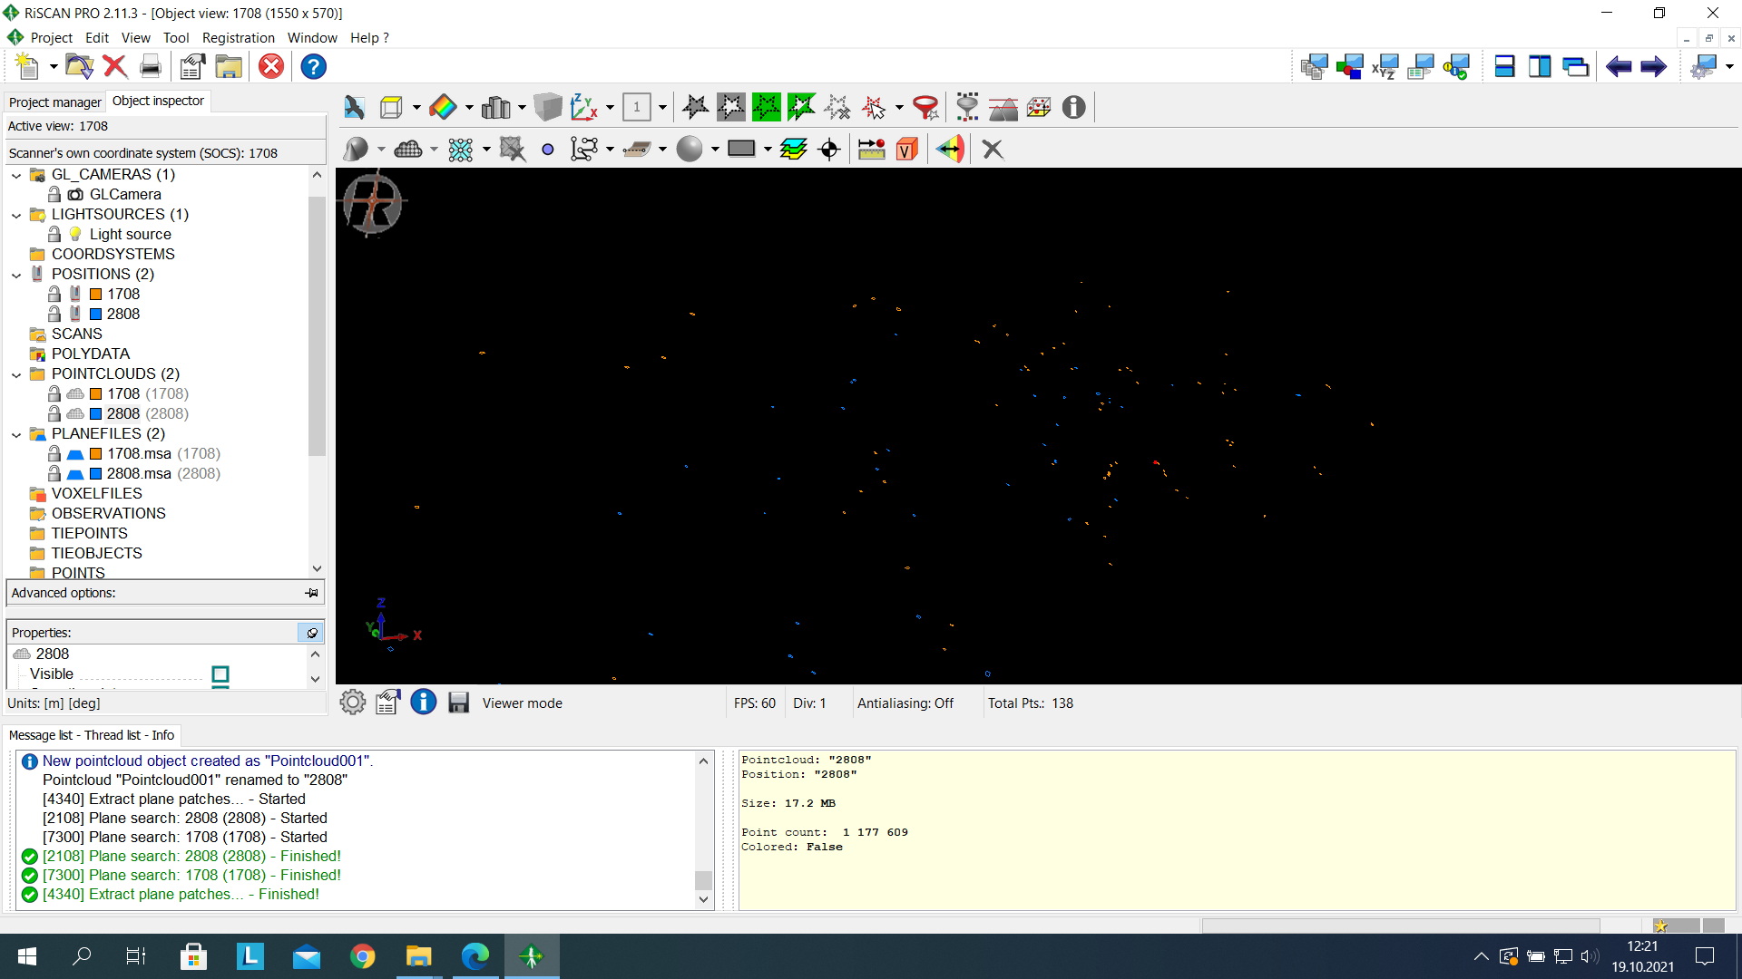

Therefore, we used a different parameter in other to extract a better plane patch covering the whole area as we can see from the image below. The total point extracted was 9036.

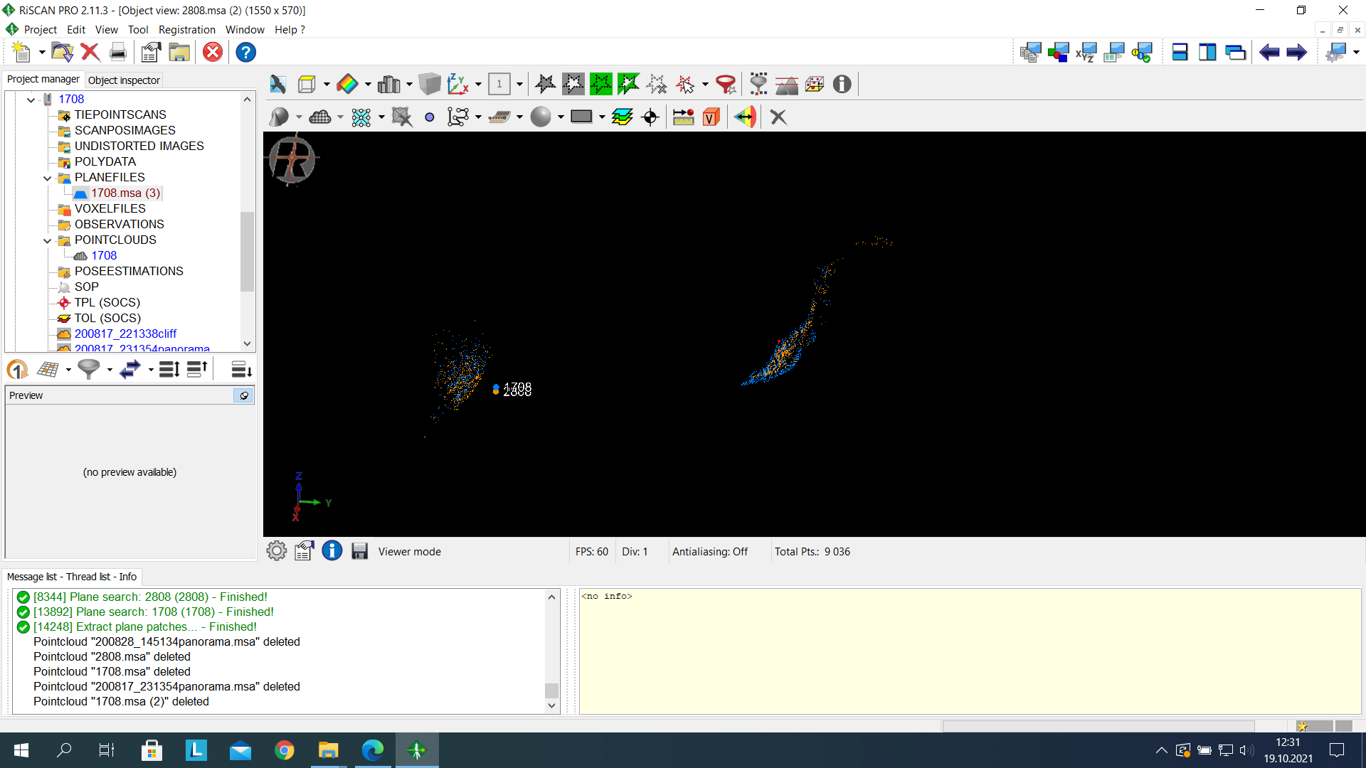

By clicking “start adjustment” we locked one of the scans which will serve as reference under the input tab, in the result tab, we set the search radius to 50 and we analyzed, we made calculations changing the search radius from 50 to 20 to 10 to 5 to 2 inputting the minimum change of error at each instance. The final result at search radius 2 was not satisfactory; the error value was at 70cm, the data cannot be registered into a coordinate system with this value, therefore another method of scan registration was introduced in the next step. Results from Multi Station Adjustment can be seen below.

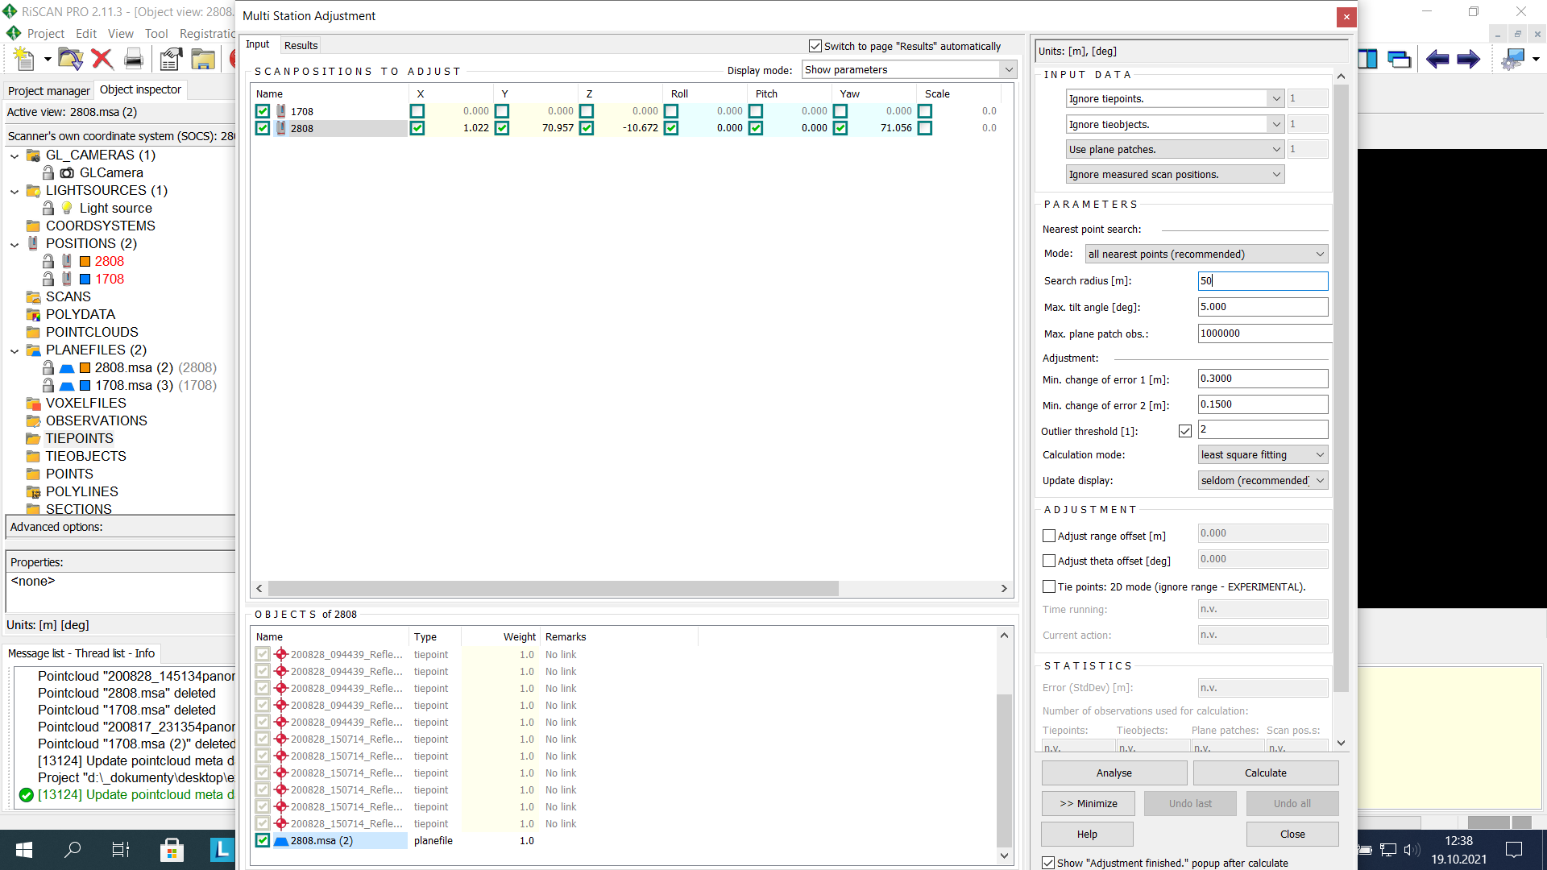

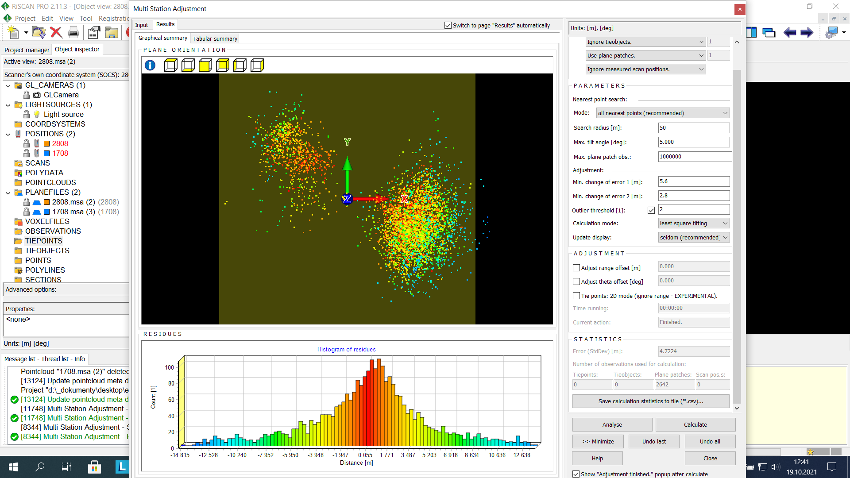

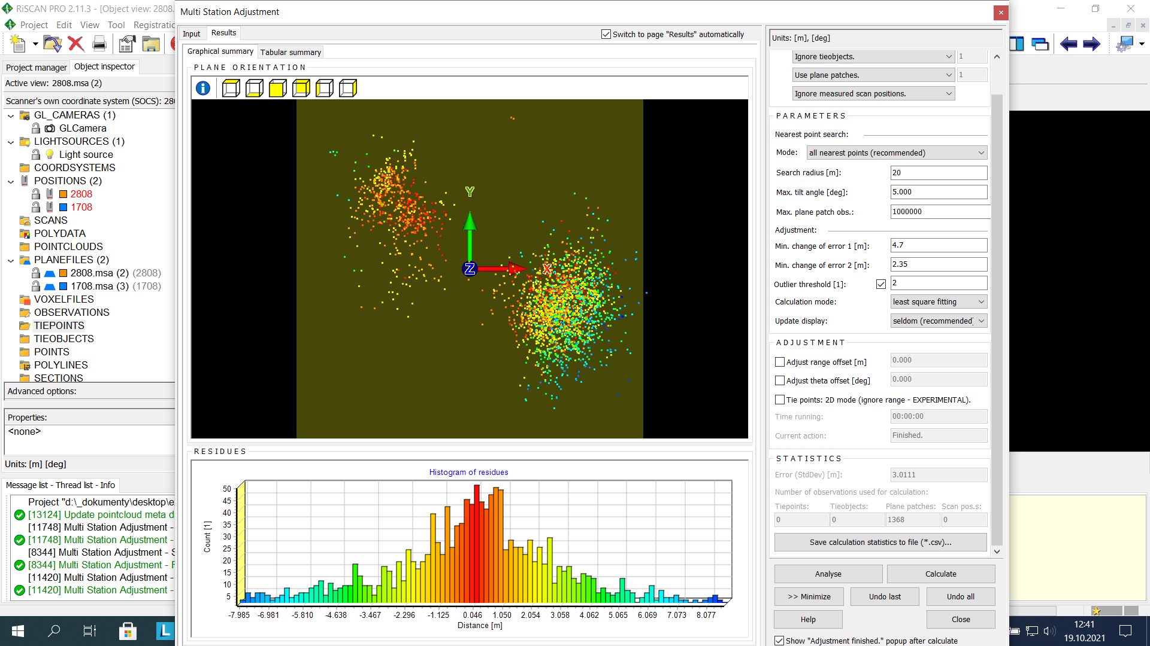

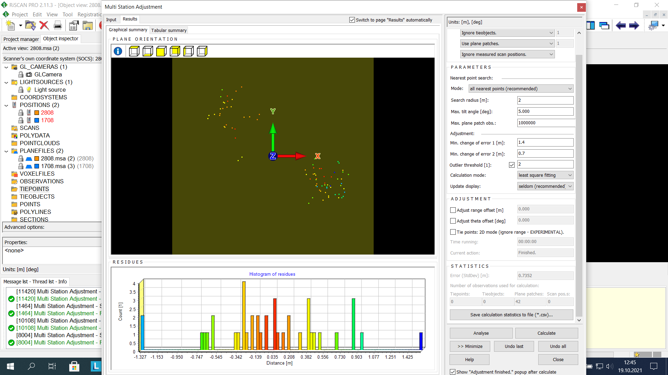

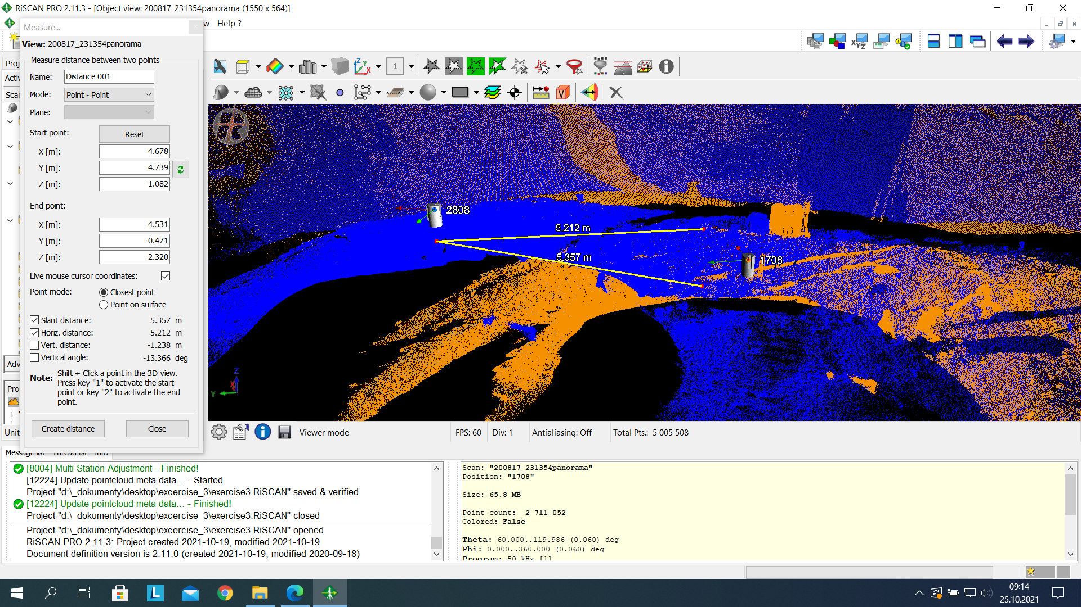

* **Registration with mesh**

Each point cloud was exported to poly data using the poly data set tool. It was named according to various date of observations.

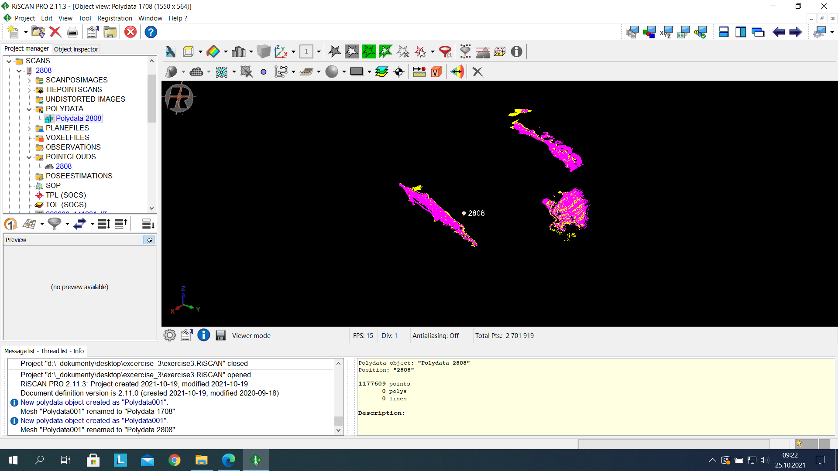

The invert selection tool was used to select all of the points of the poly data set. To create a mesh, we used the triangulation mesh tool.

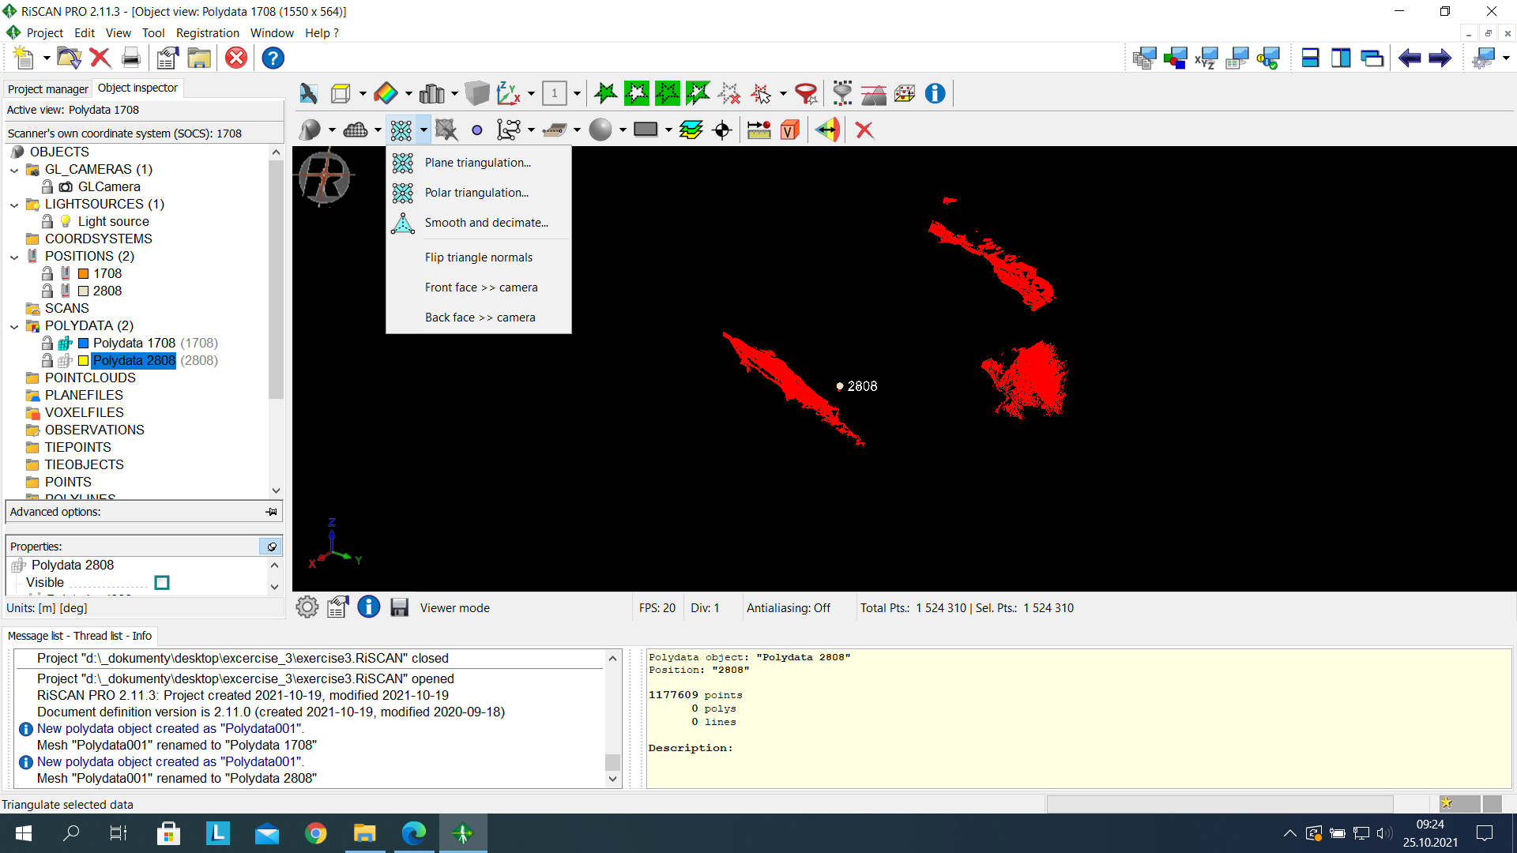

In the triangulate data window, we set the Maximum triangle edge length to 30, maximum triangle tilt angle to 80, minimum triangle angle to 1, then Triangulate.

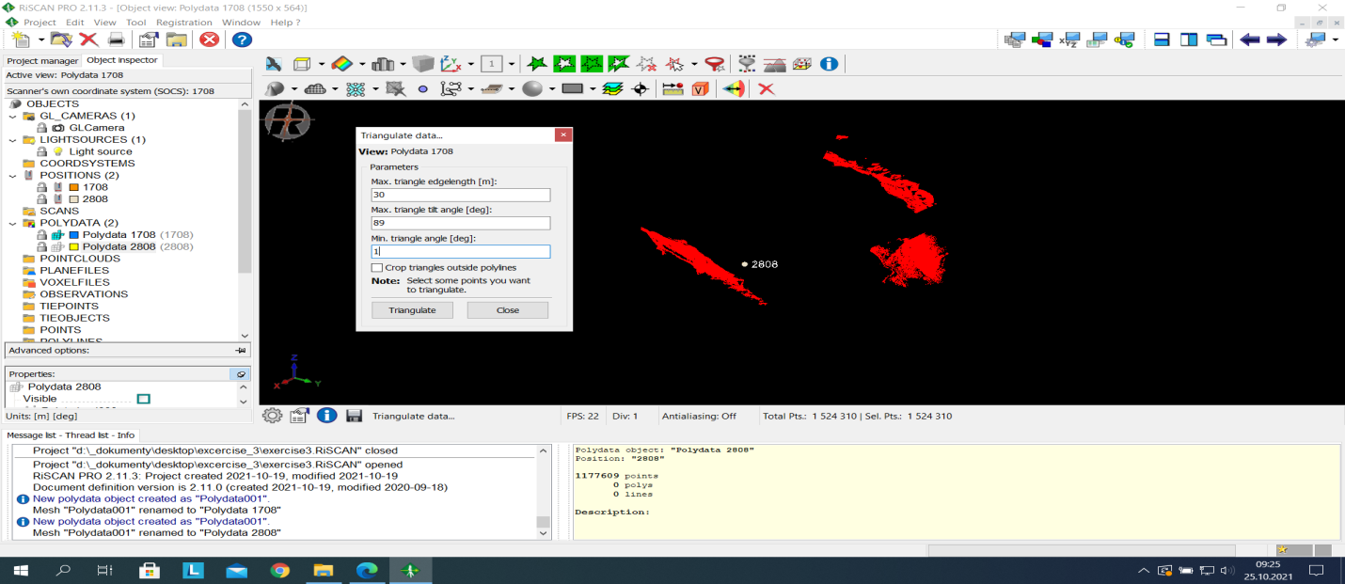

Displaying the results we have the image below.

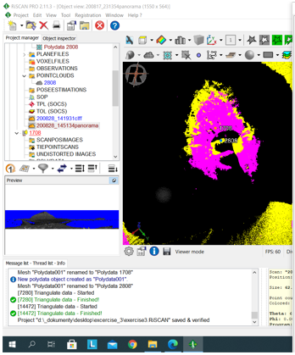

Using “start adjustment” under Multi station Adjustment, we locked one of the scans which will serve as reference, in the result tab, we set the search radius to 20 and we analyzed, we made calculations changing the search radius from 20 to 10 to 5 to 2, I continued the analyses to 1 and to 0.5 inputting the minimum change of error at each instance. The final result at search radius 0.5 was satisfactory; the error value was at 10cm.

It was observed that as we changed the search radius and the minimum change of error, the scan positions moved closer to each other as can be seen from the image below.

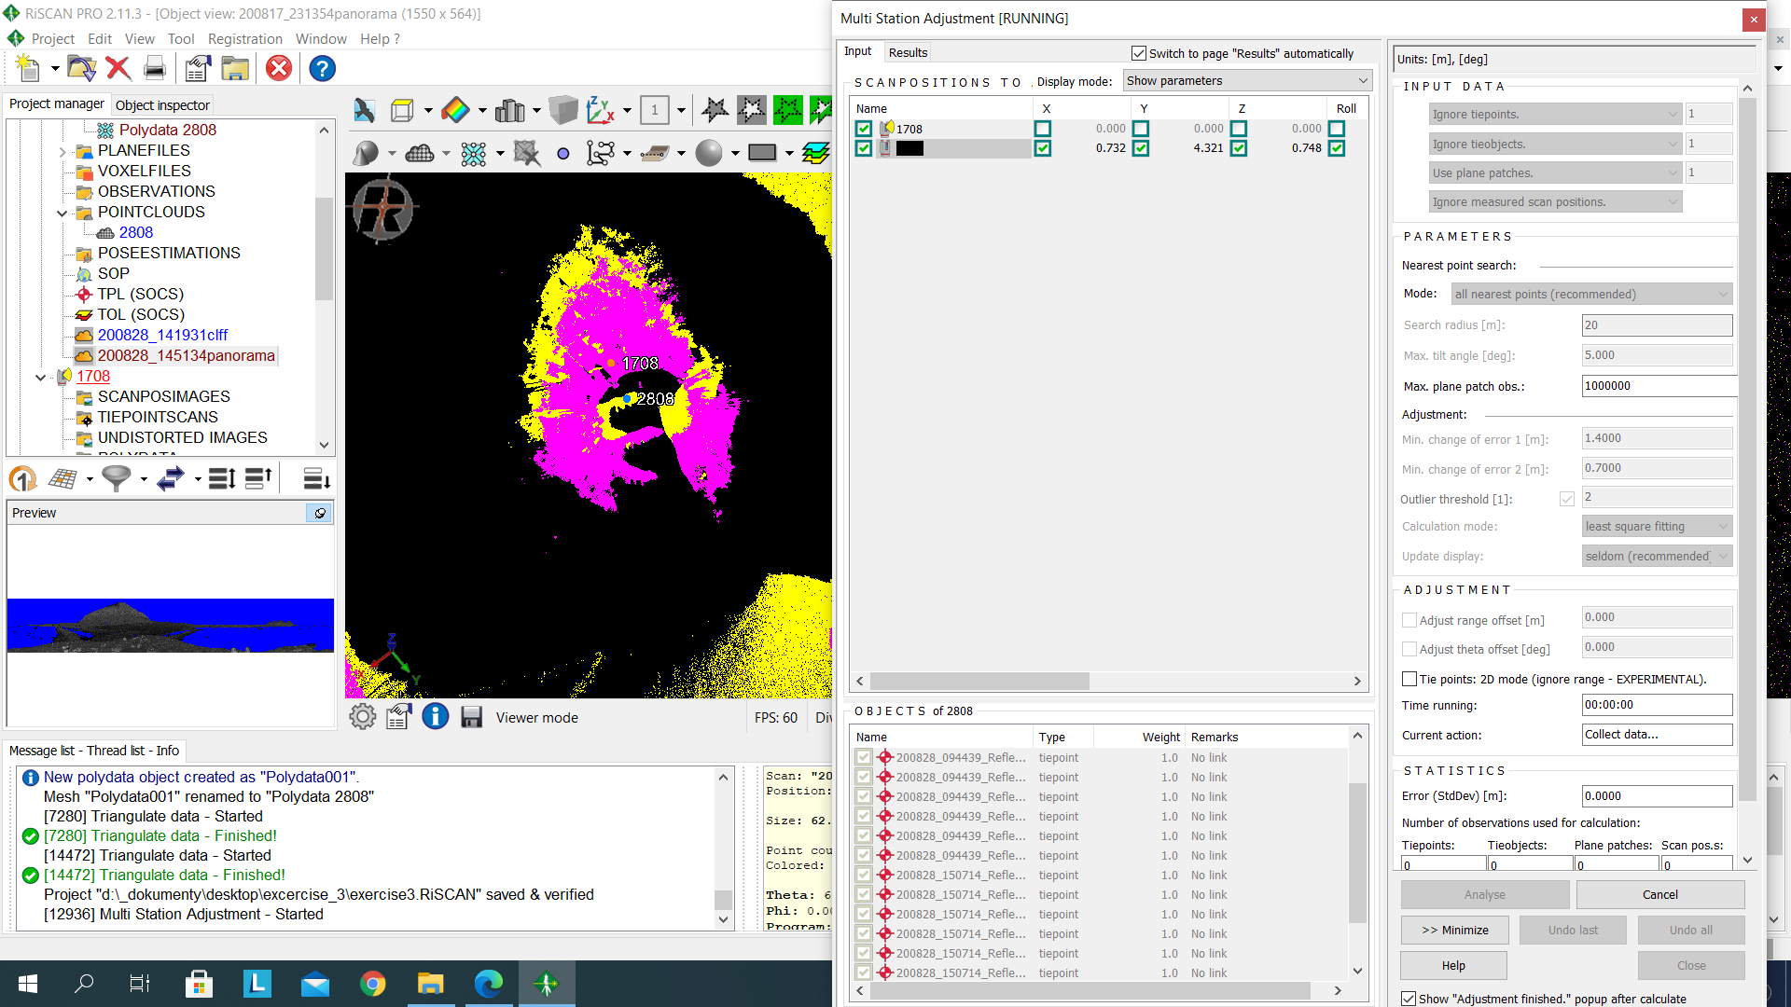



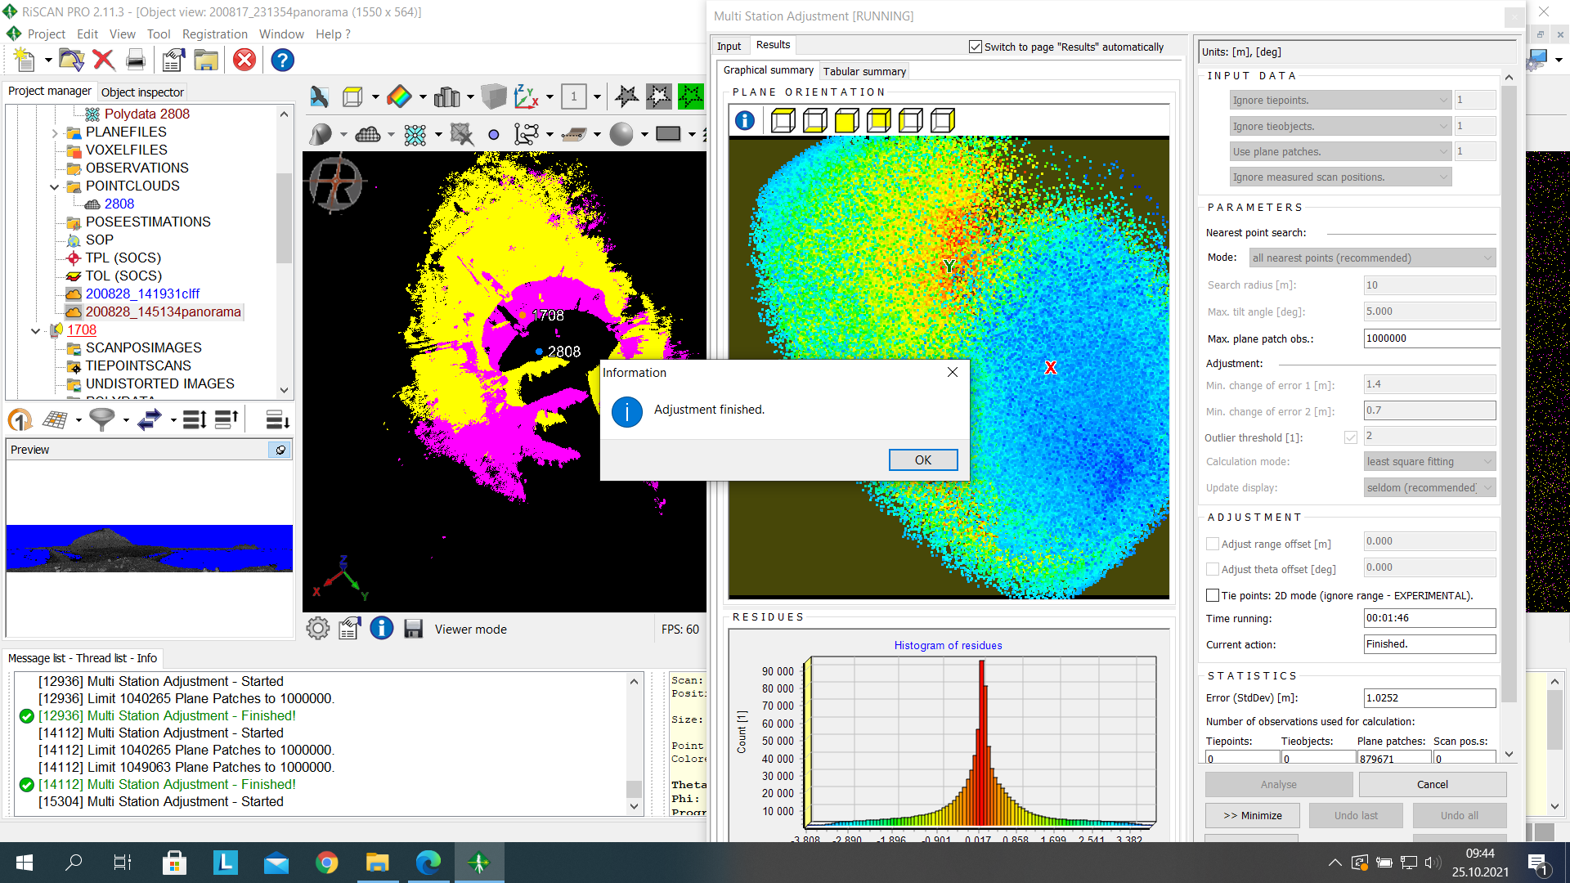

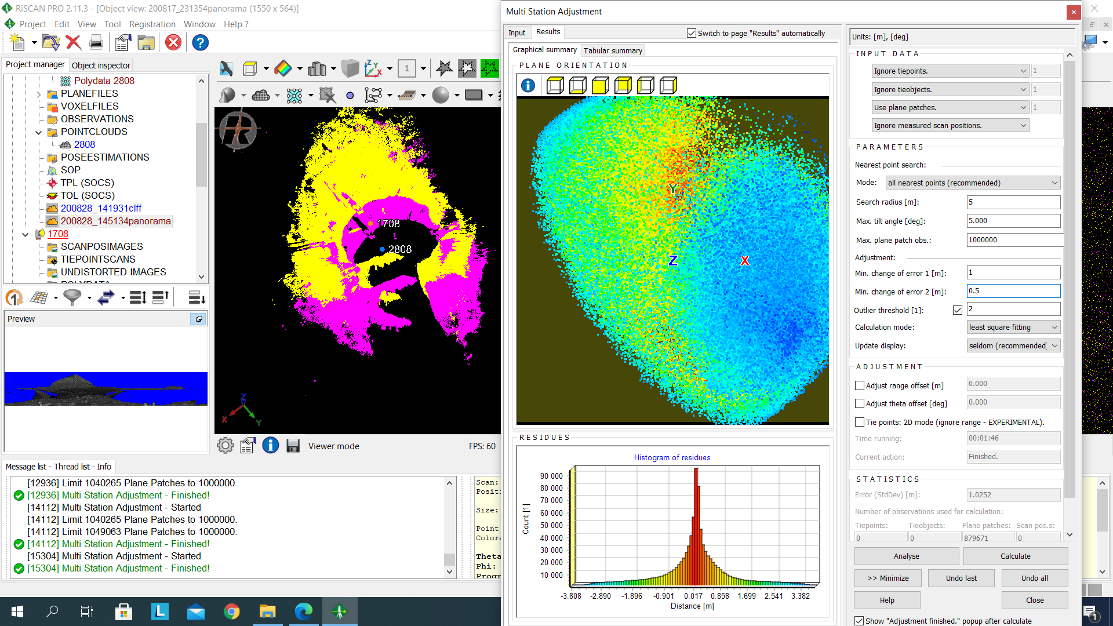

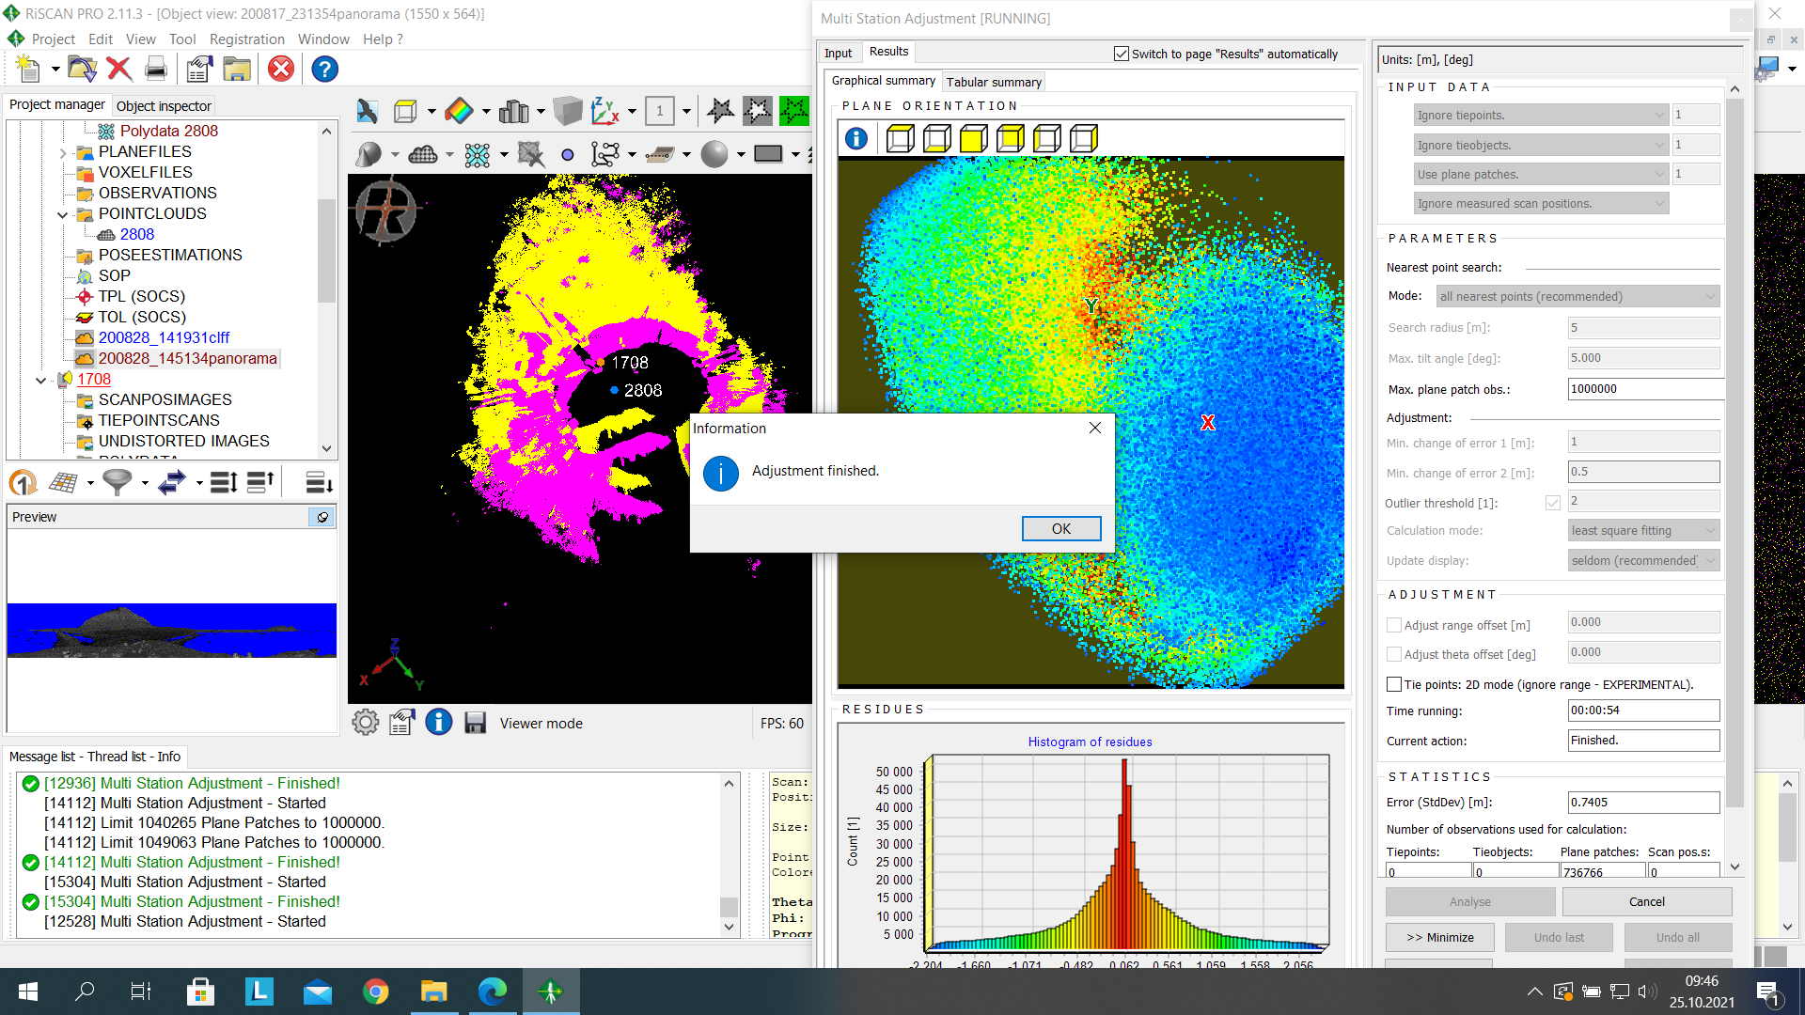

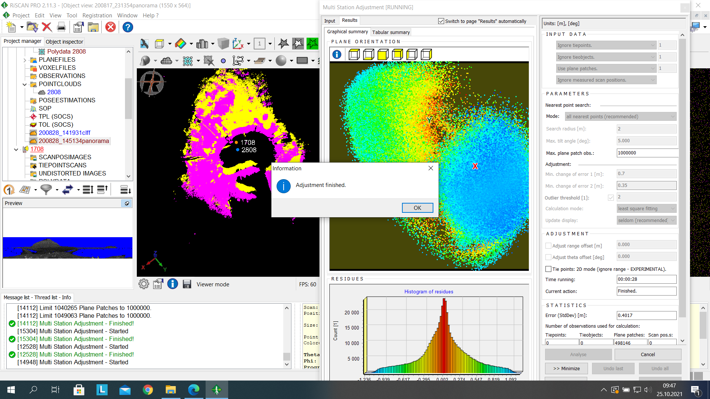

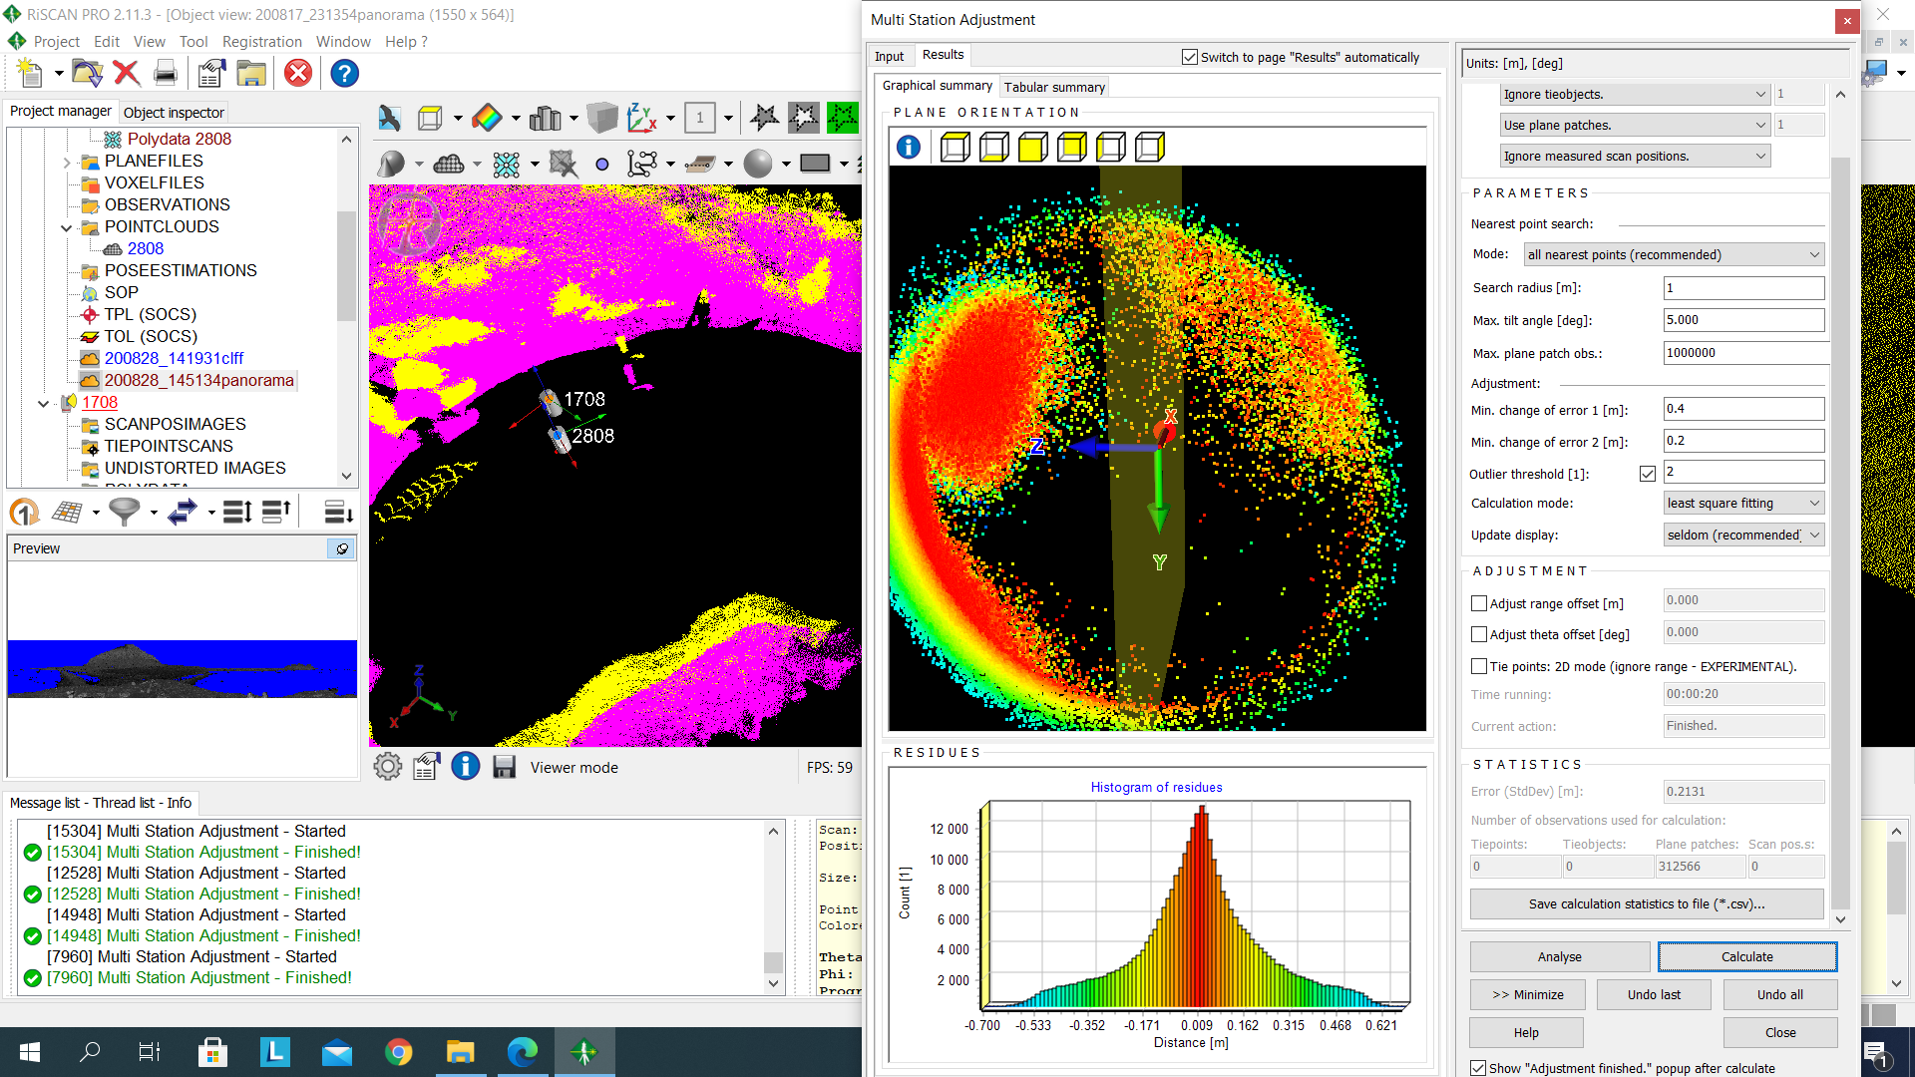

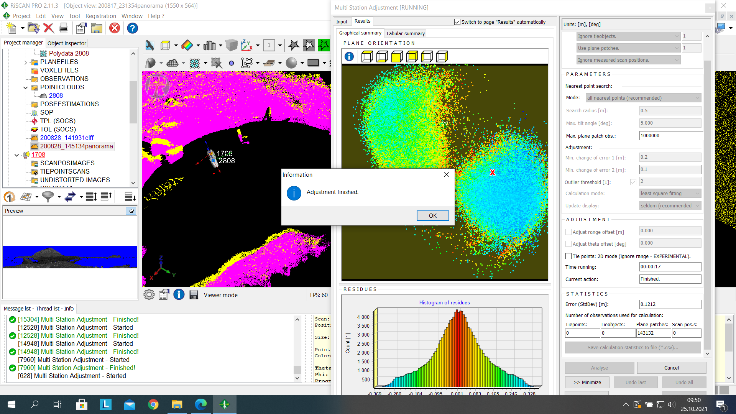

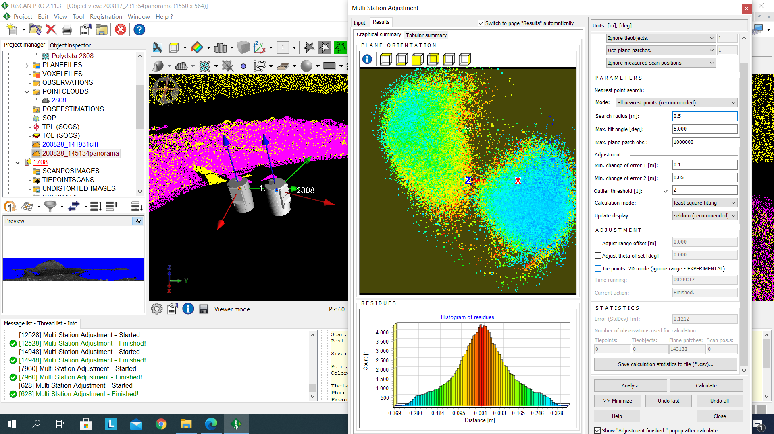

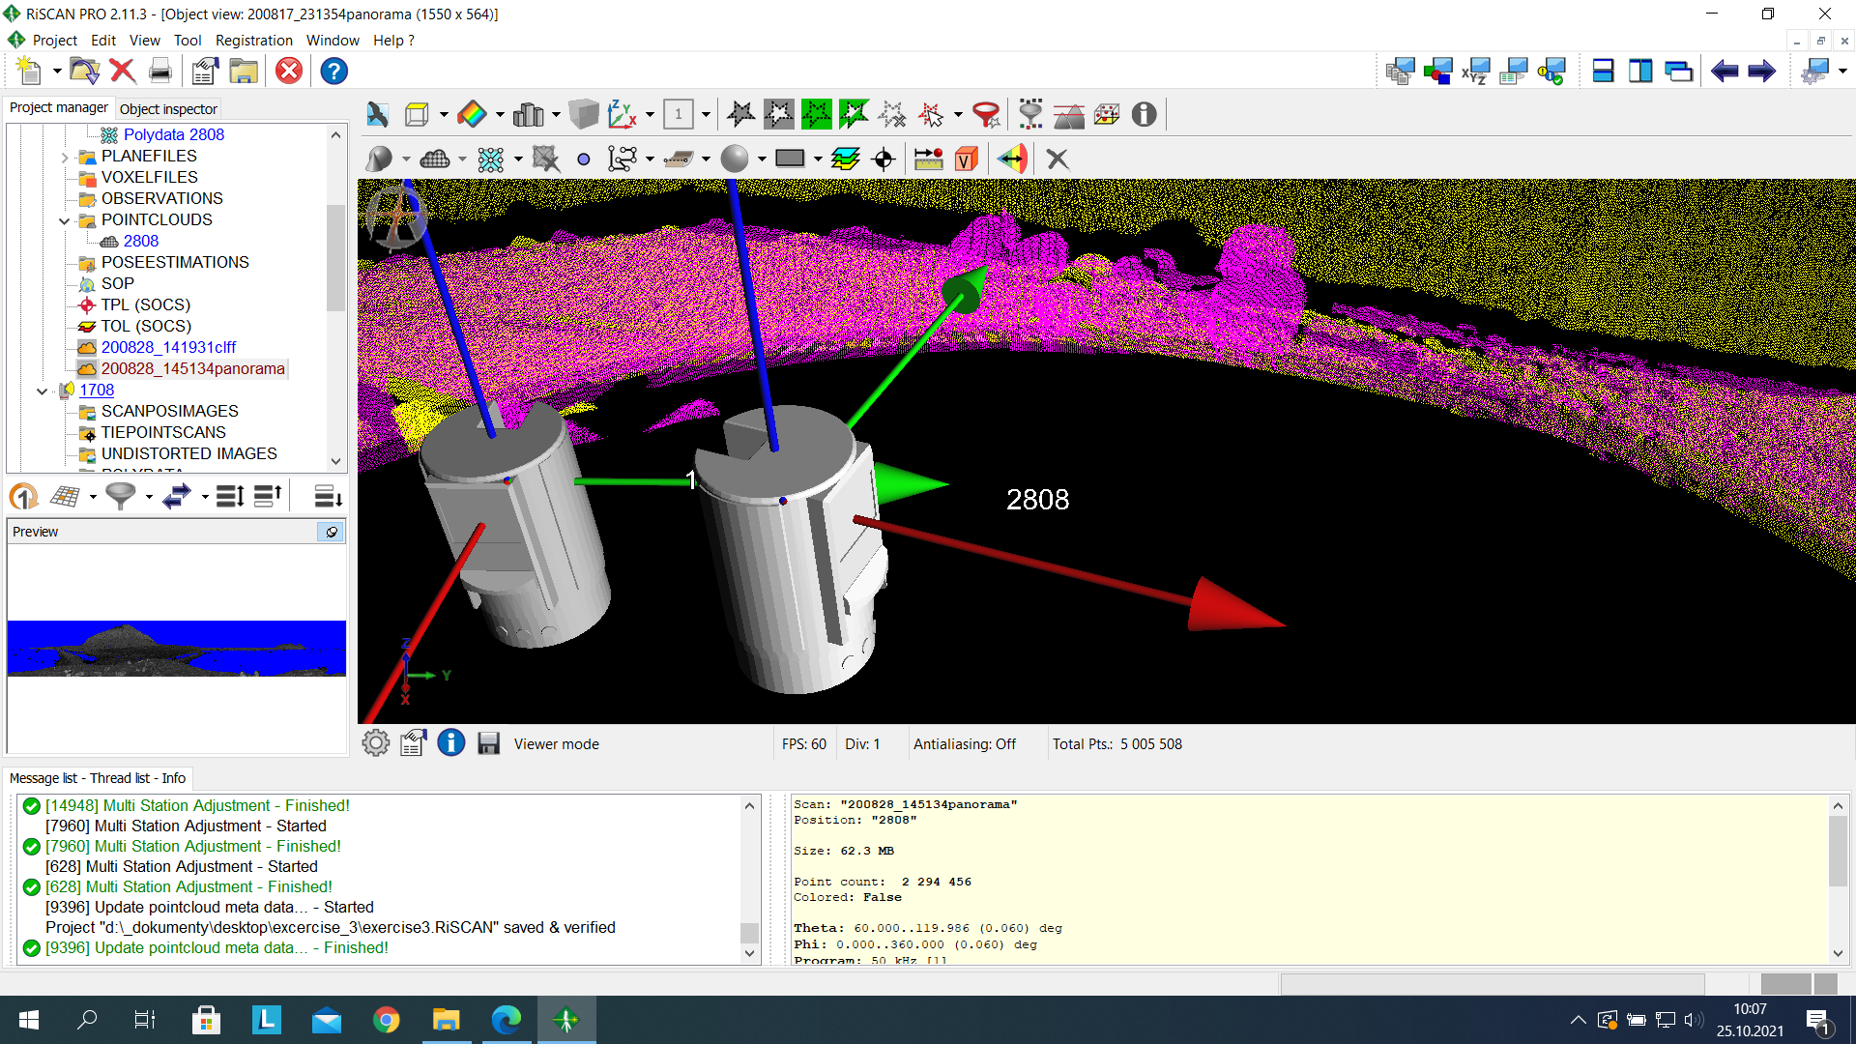

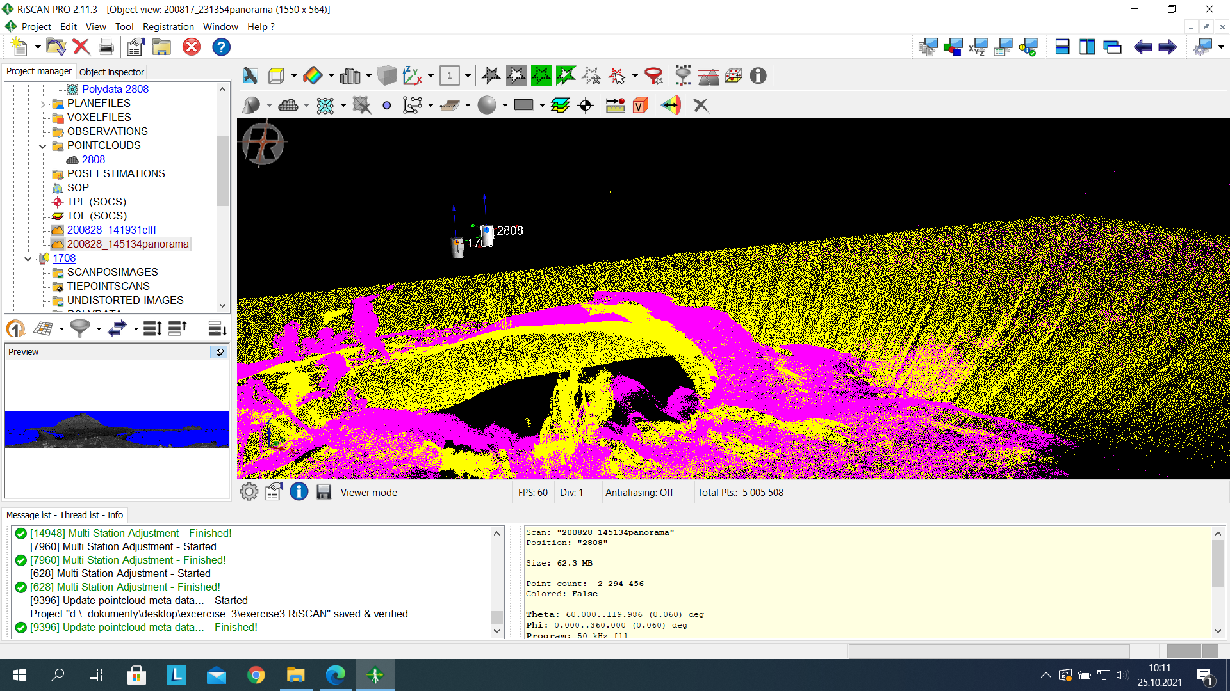

* **Measurement of glacier front displacements**

We set both point clouds to orthogonal projection and we created a plane perpendicular to the crevasses from two points using the plane creation tool. The plane was created under the planes folder.

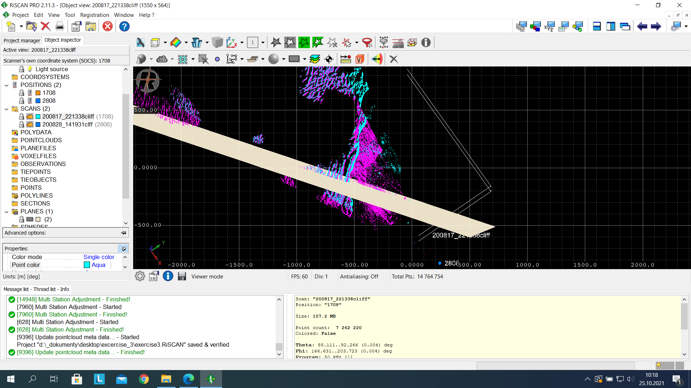

We turned off the plane and used the height filter tool to set the height range from 5 to -5 with respect to the plane.

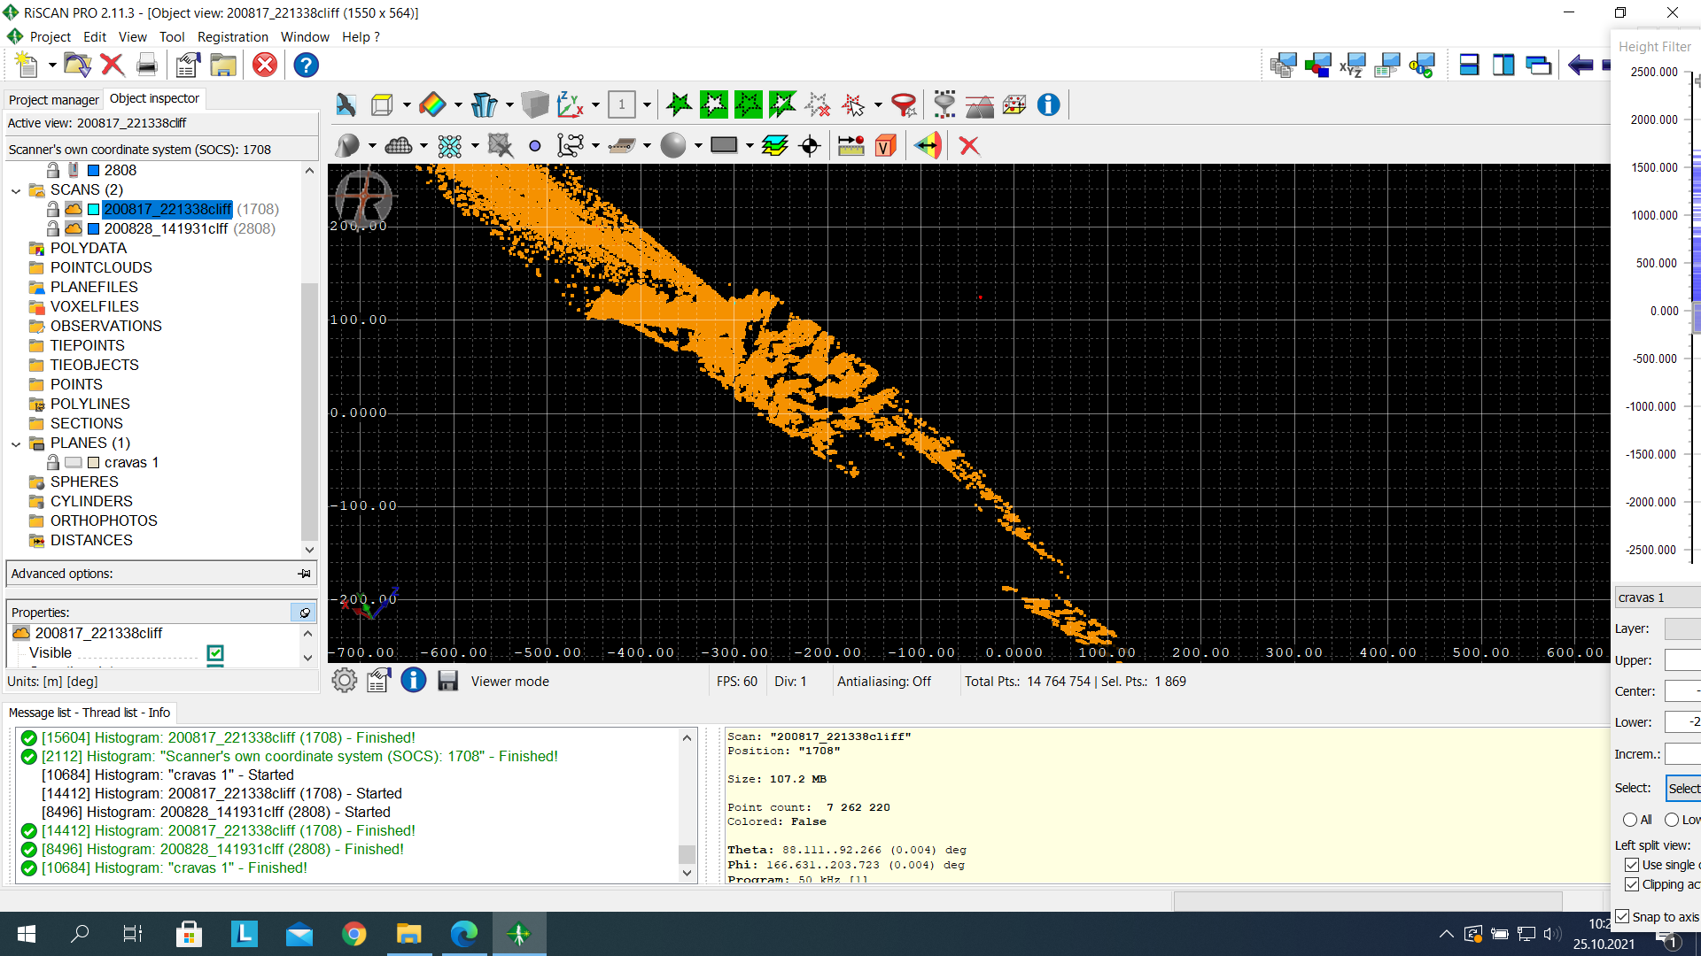

In order to analyze the glacier velocity, the selected point was exported into new point clouds for both scans. The two new pointcloud was displayed using single colors and we zoomed closely into the crevasses in order to see the displacement pattern and to also make measurement of the changes.

Using a point as the origin, measurements were made at different intervals starting from the origin and the changes between the glacier velocity for the two scans were noted. Below are the screenshots of the measurements made.

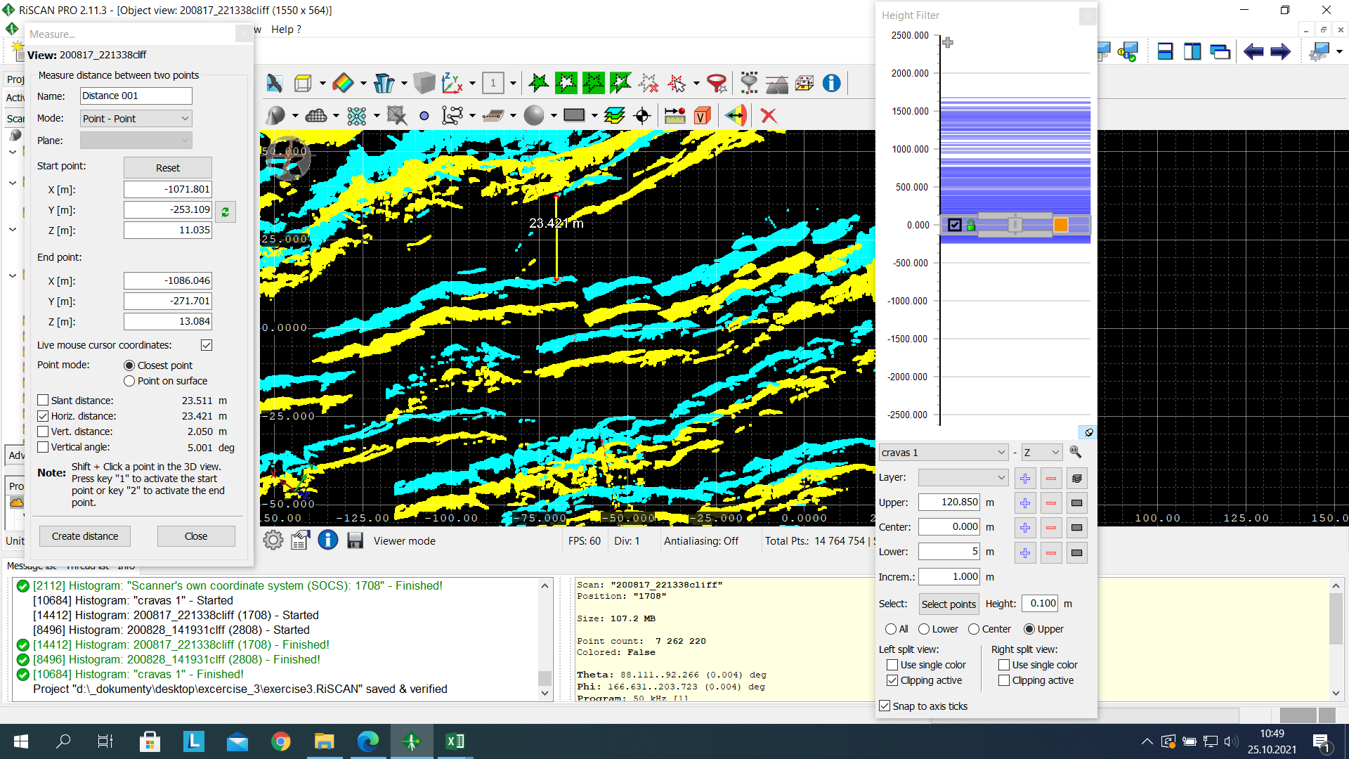

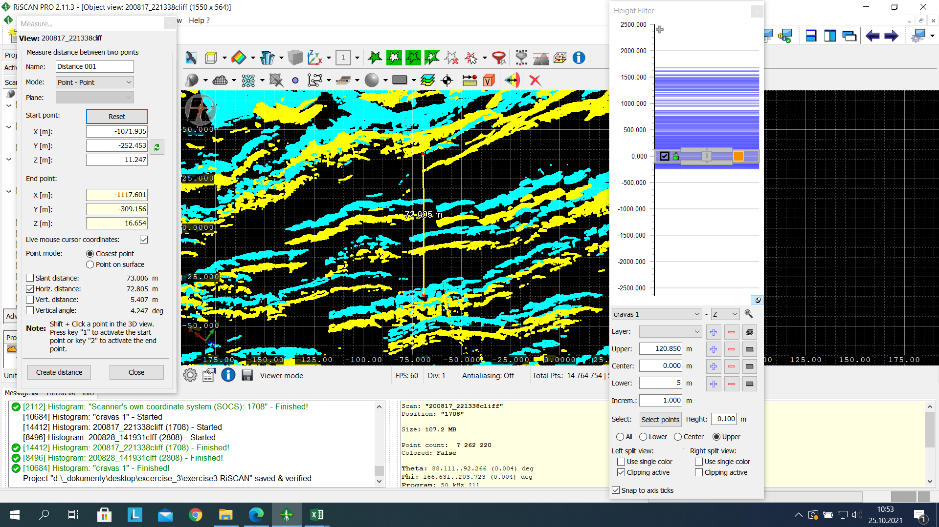

These measurements were inputted into Microsoft Excel. Column A represents the intervals starting from point 0, column B represents the glacier front displacement at different intervals and column C represents the speed of the glacier, this was derived by dividing column B by the number of days (11) between the two scans.

The interval was plotted against the glacier speed to produce a graph which can be seen below. The graph shows that point 0 represents the point with the highest velocity, therefore there is an increase in movement around this region. The graph shows that the speed reduces as the interval from point 0 increases.

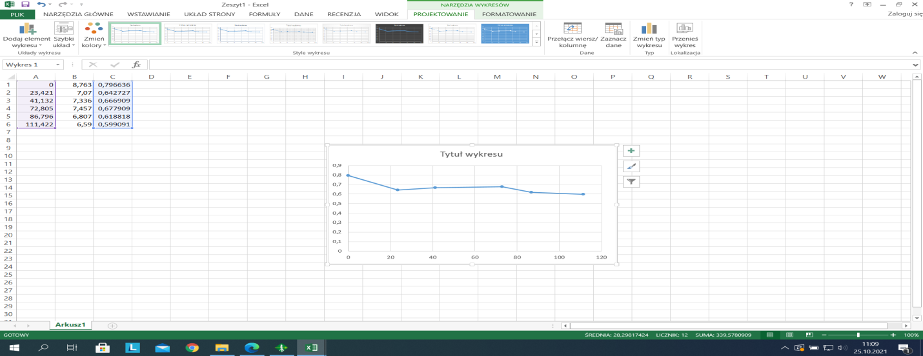

* **Calving size based on voxels**

This operation displays pixels in 3D, the cliff of both pointcloud was opened and by right clicking the scan, we selected the extract voxels option.

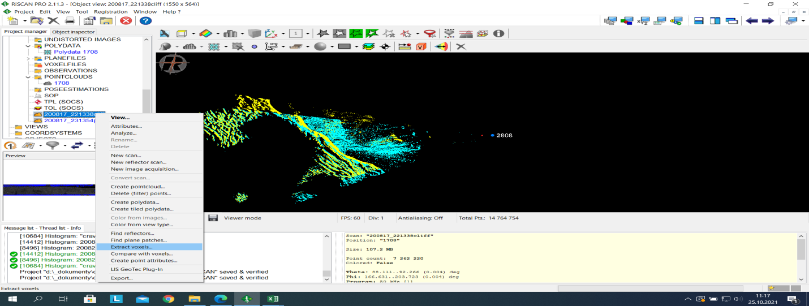

In the Extract Vowels window, we select the pointclouds and we set the voxel size to 0.5, min. point per voxel to 3, minimum deviation to 0, maximum deviation to 20, plane threshold to 0.5, line threshold to 4.0, then OK.

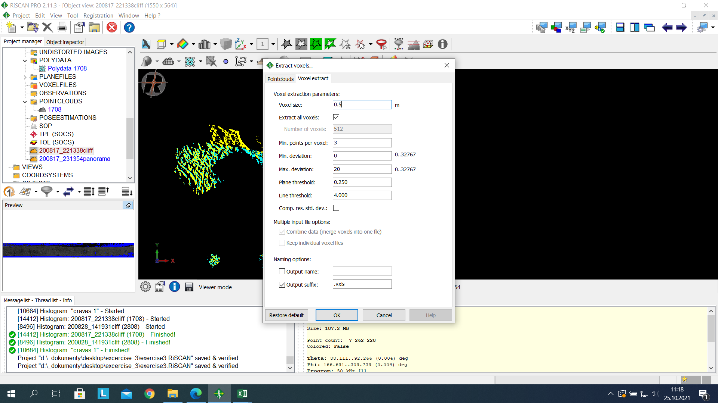

We then have the result.

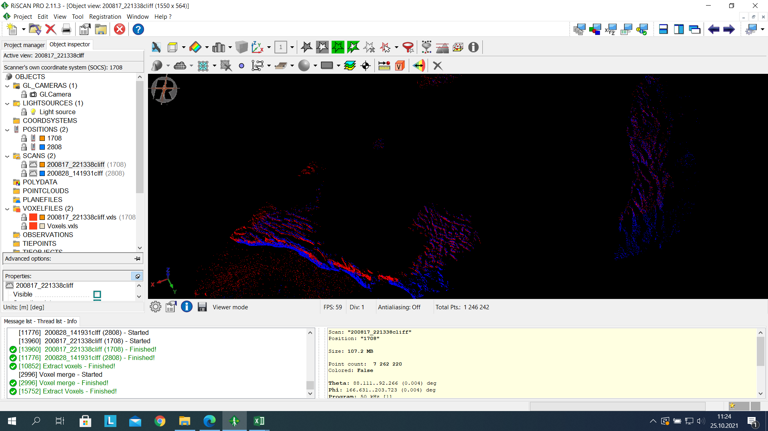

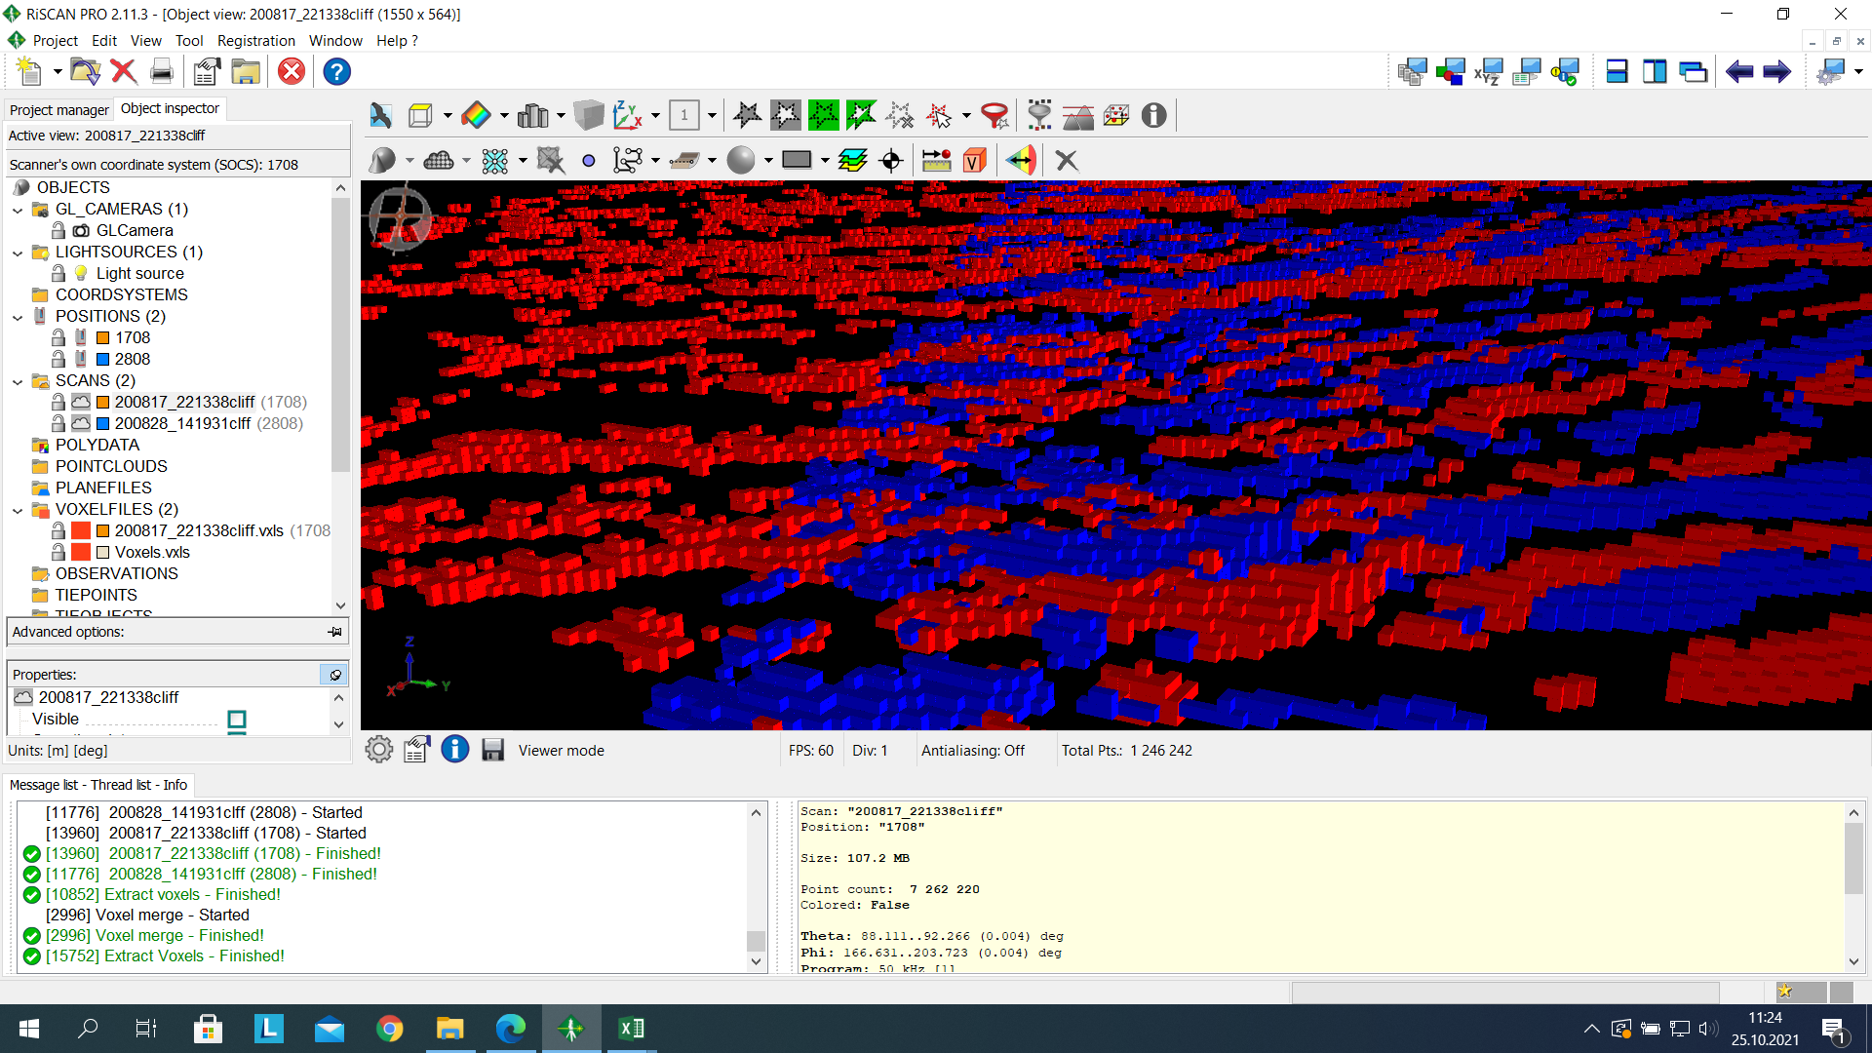

To compare the voxels, right click on voxelfiles of one pointcloud and click on compare with voxels, choose the other pointcloud and set the maximum distance to 10. The result can be seen below. The result shows where the "mass" was added and where it decreased in relation to the analyzed scan

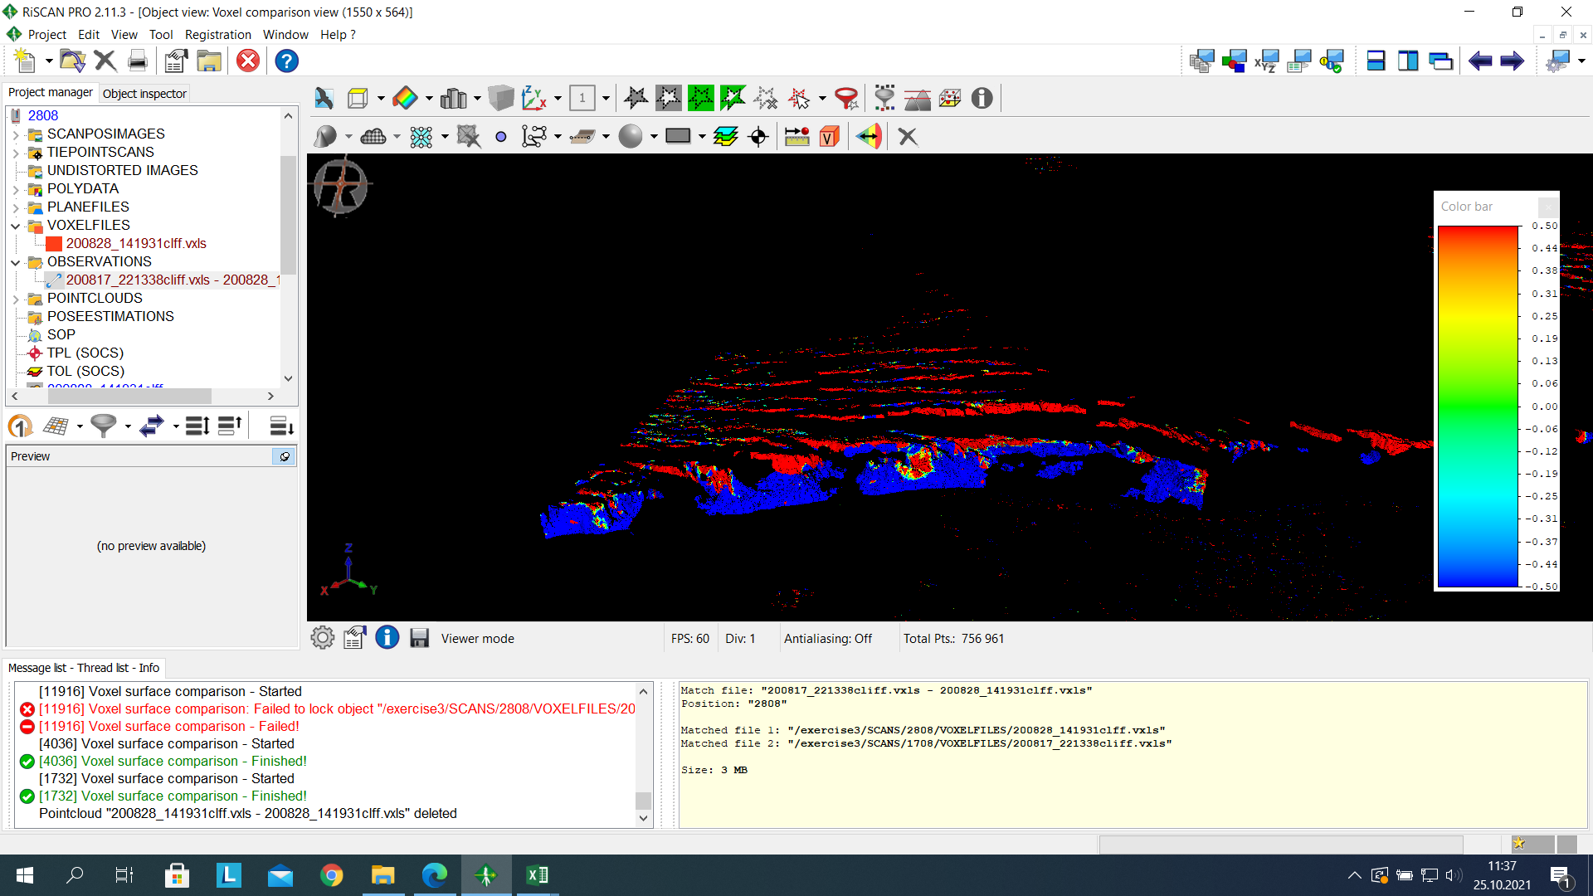

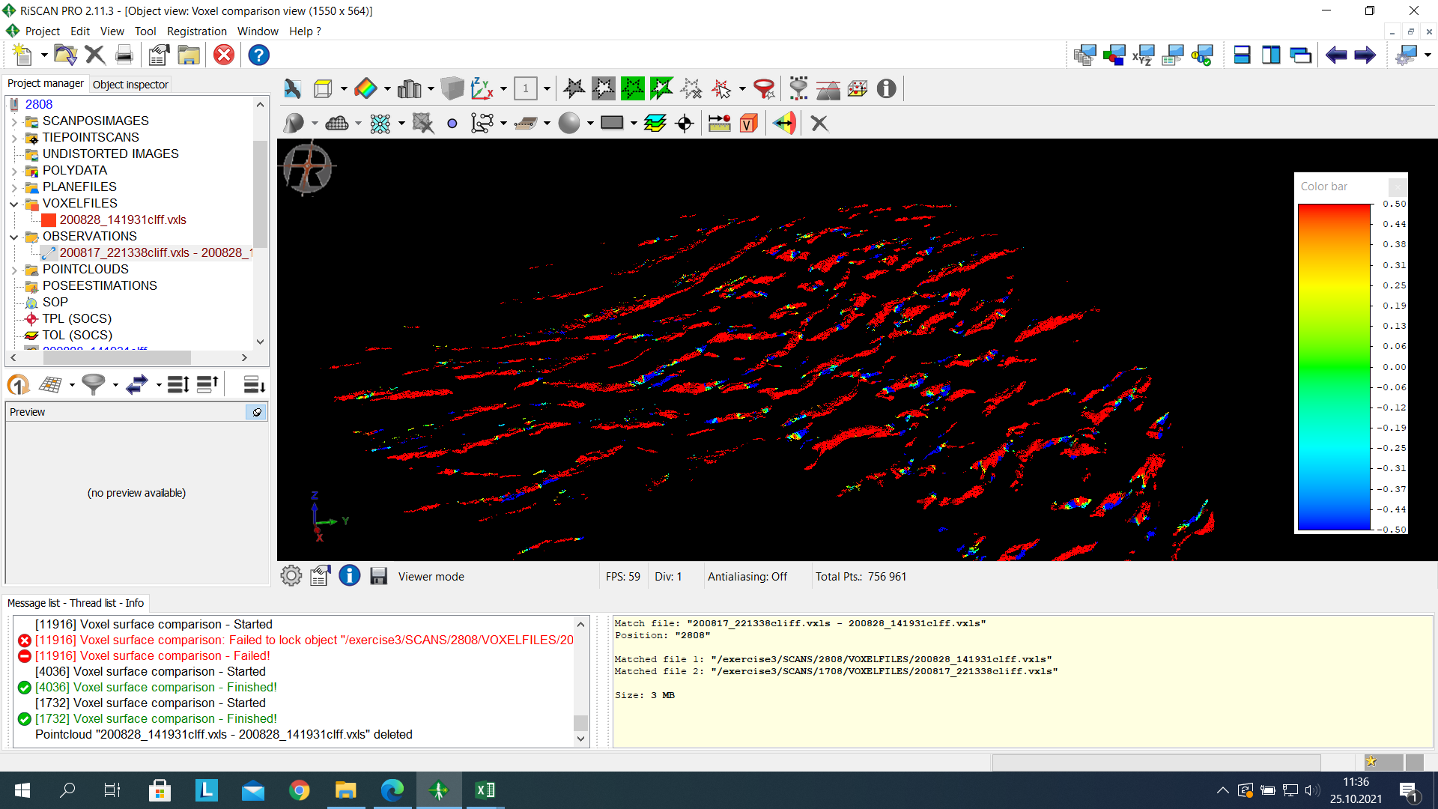

The voxels intensity is used to analyze the direction in which the shift occurs.

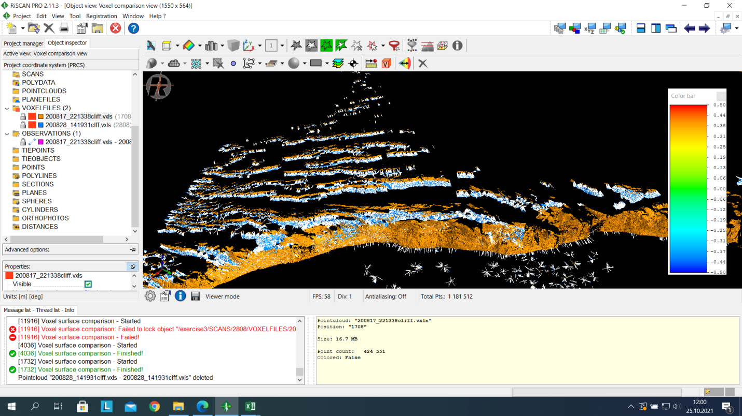

* **Transformation to the global system**

The aim of the stage is to transform the coordinate system of points from scanner’s own coordinate system to Global coordinate system. This will enable data visualization in ArcGIS environment. We already have the position of spotlights obtained using differential GPS during field observation. These points can be found under the tiepoint scans folder in the Riscan software, we previewed the reflector positions and observed that some of them are in the wrong position so they have the “bad” tag on their name. Detailed information about the spot light can be found when we open the (TPL-SOCS) option. The tiepoints positions on the pointcloud can be seen by dragging the TPL (SOCS) into the open window containing the pointcloud.

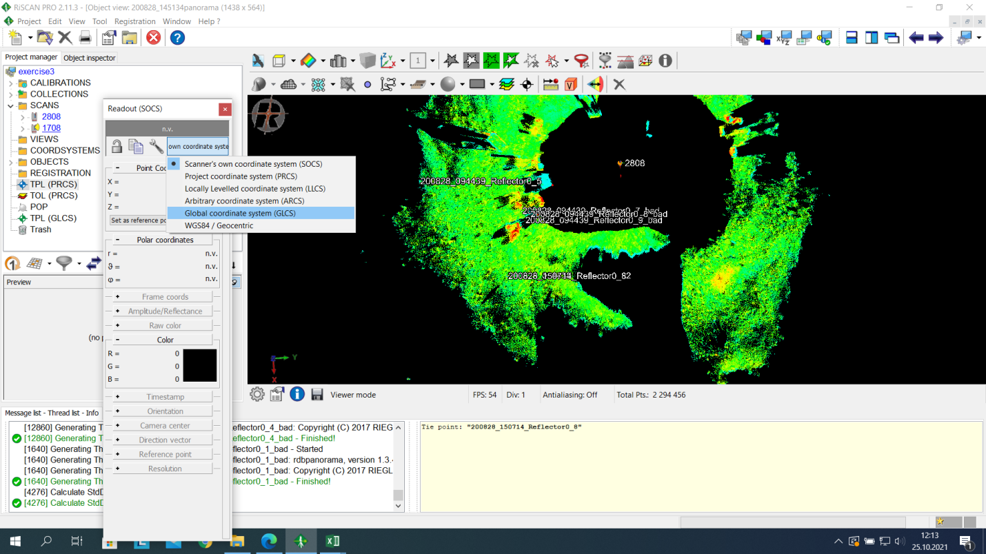

Next stage of the transformation was to export the tiepoints list from TIEPOINTS (TPL-SOCS) to (TPL - PRSC), this was achieved by selecting the reflectors in TPL (SOCS) and copy to TPL (PRSC).

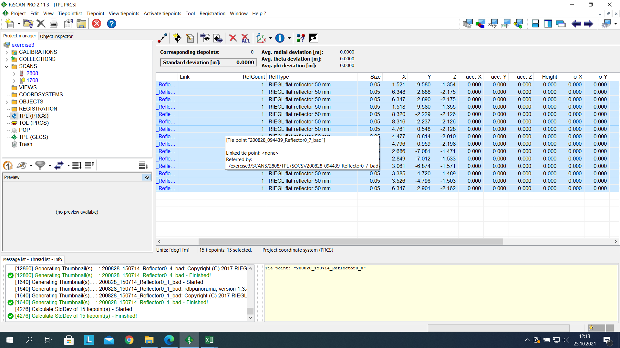

We imported "global" data to the project, this global data was imported as CSV file, tabulator was chosen as the column separator and there was an option to indicate the number of lines.

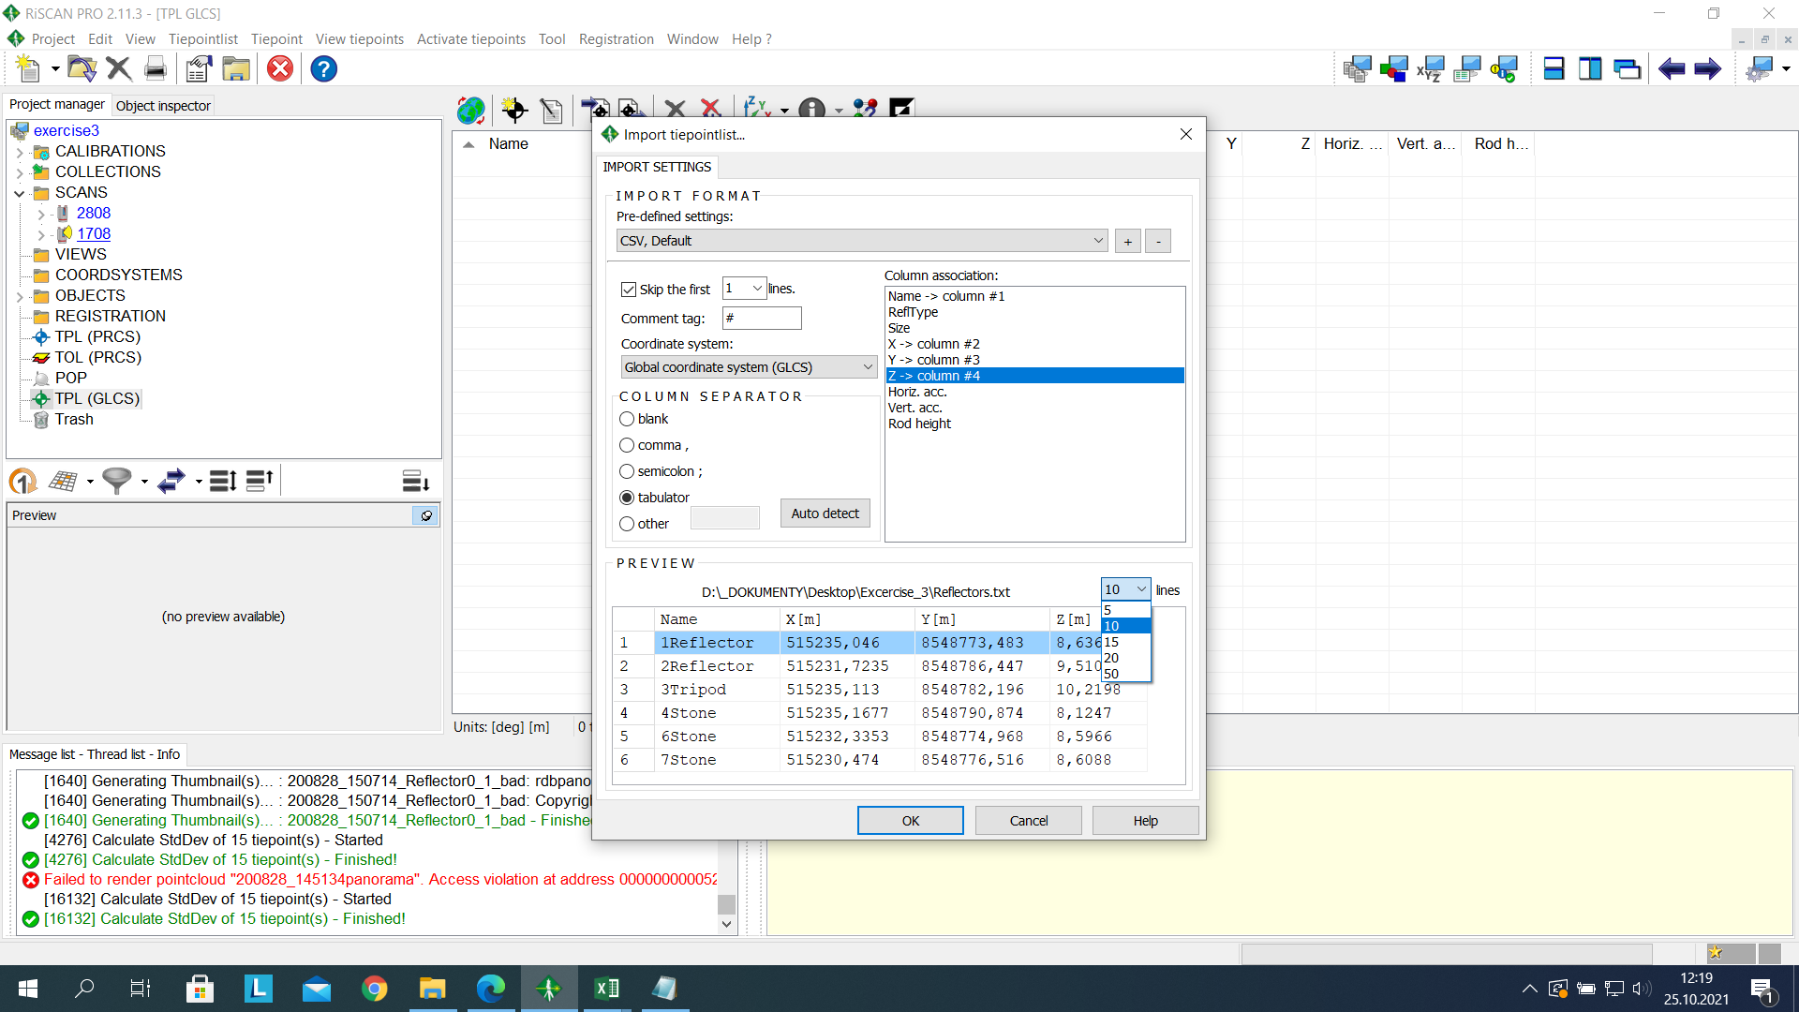

We opened both TPL (PRCS) and TPL (GLCS) windows and selected Find corresponding points function. The tolerance was set to 2 and 4 was chosen as the minimum number of points to have the accuracy with which we fit the data into the global system.

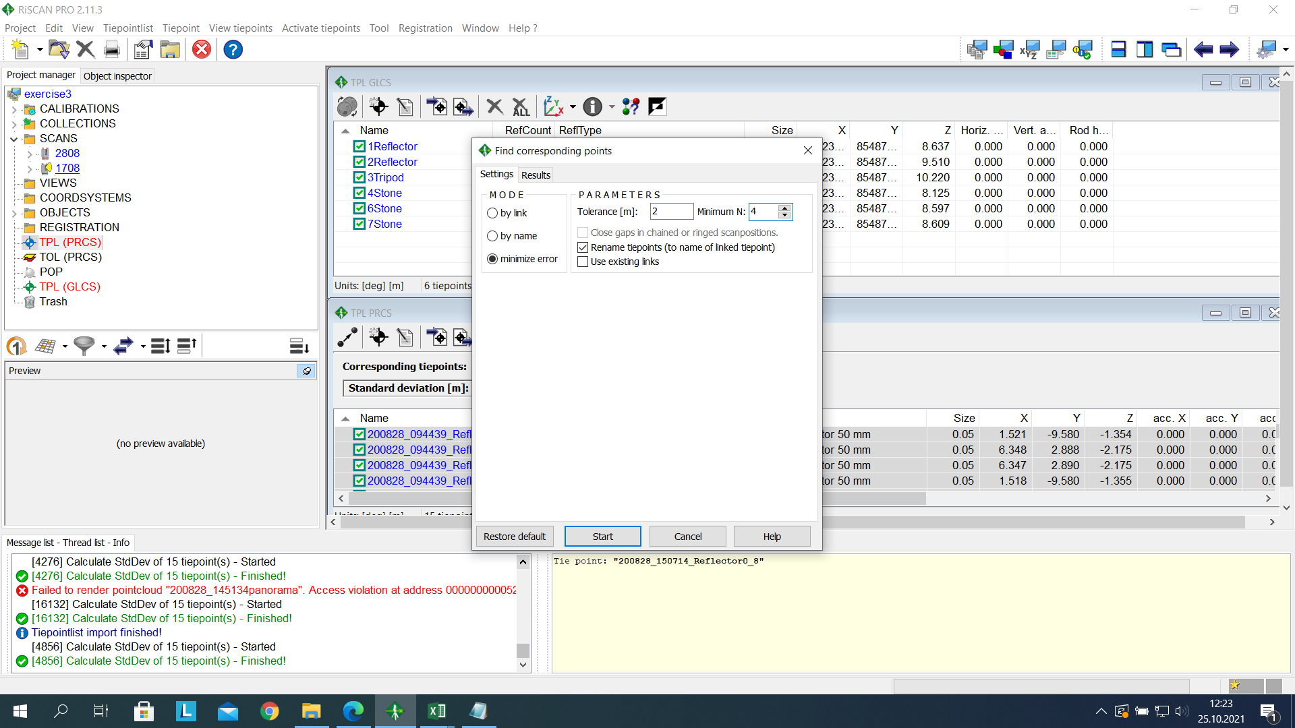

By clicking start, the calculation was made, the Standard deviation was at 0.8 m and the number of corresponding points found was 4.

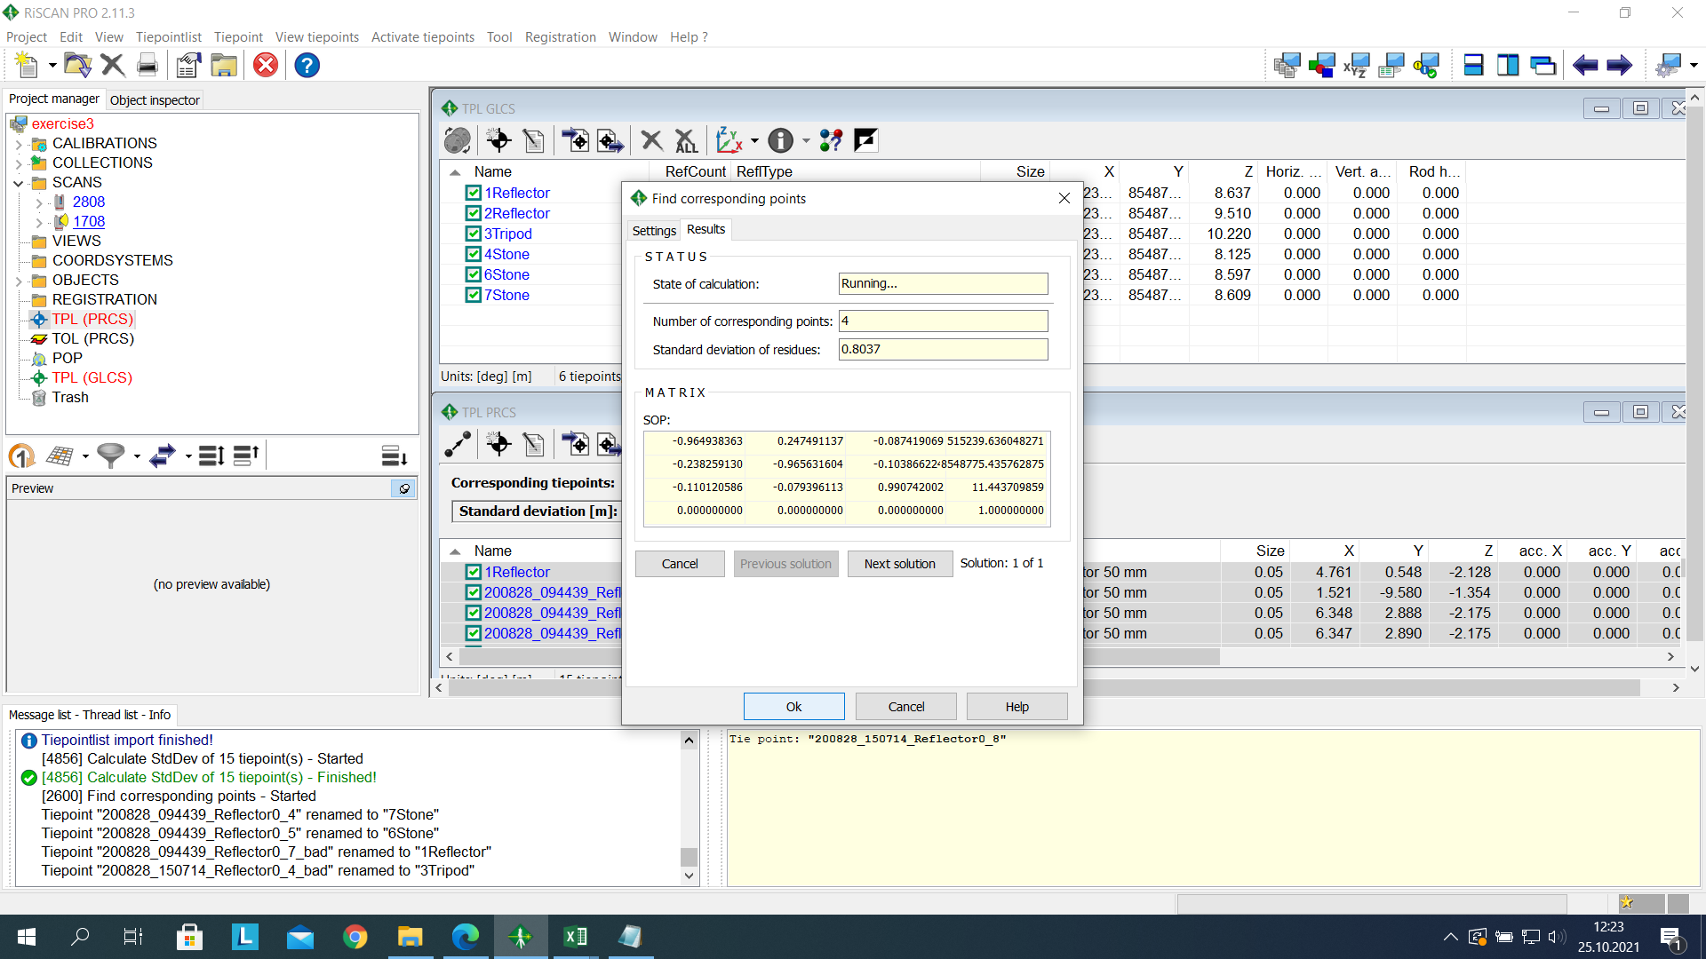

We can check the coordinate of any point on the pointcloud by right clicking on view and selecting data read out. If we click on any point, we will see the resulting coordinate system in the dialogue box.

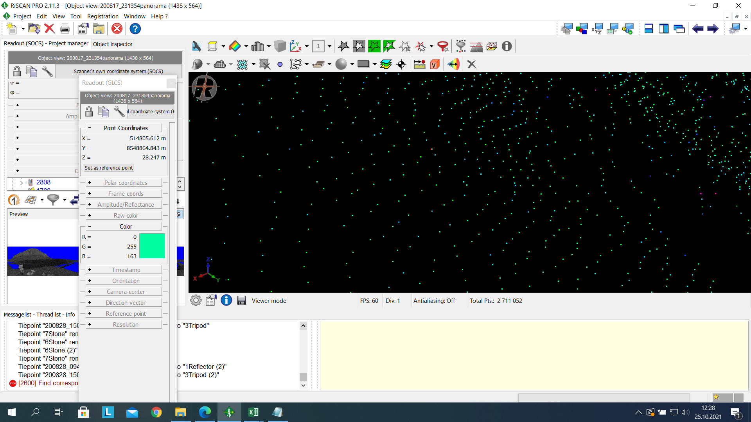

* **Visualization of Data in ArcGIS Environment**

The panorama of both scans was exported into .ascii and .las format. It was later imported into the ArcScene and ArcMap environment. Data processing was not possible in this software, therefore data was only visualized. In ArcScene, LAS dataset option was used to edit the .las data for visualization.

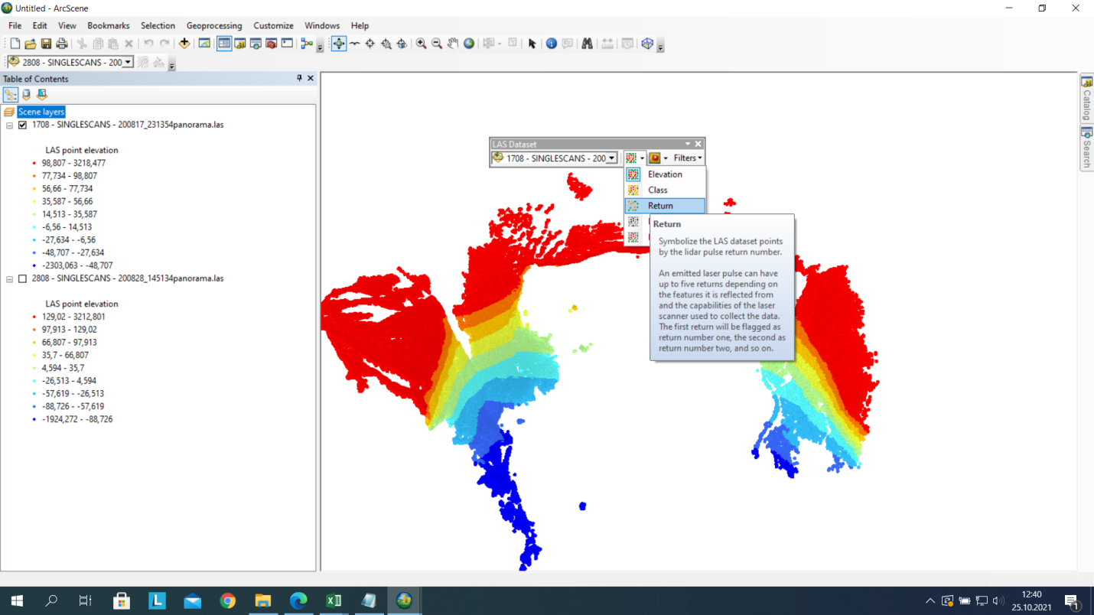

.las dataset was also visualized in ArcMap. It was converted to multipoint shapefile using LAS to multipoint in Arc Toolbar.

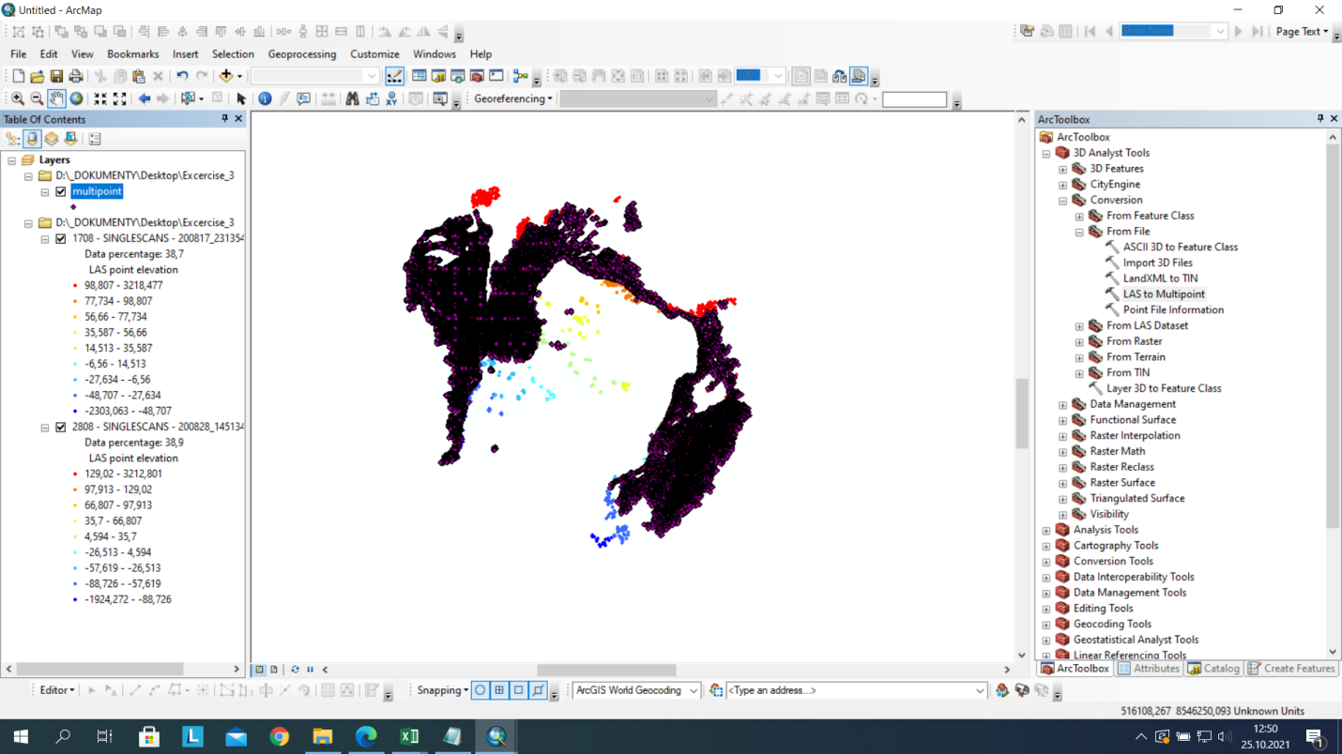

.ascii dataset was visualized in ArcMap using the Arc toolbar (ASCII 3D to Feature Class).

